UNIT 1
Introduction – Uses – Network hardware – software – reference models – example networks – Theoretical basis for communication – transmission media – wireless transmission – Communication satellites

What is Computer Network?

A communication network is a set of nodes connected by links and able to communicate with one another.
- A computer network is a communication network in which nodes are computers.
- The purpose of the network is to serve users, which can be humans or processes.
- Network links can be point-to-point or multipoint and implemented with several transmission media.
- Information exchanged can be represented in multiple media (audio, text, video, images, etc.)
- Services provided to users can vary widely.

APPLICATIONS OF COMPUTER NETWORKS:
- Business Applications
- Home Applications
- Mobile Users
- Social Issues

1. BUSINESS APPLICATIONS:
- Many companies have a substantial number of computers. For example, a company may have separate computers to monitor production, keep track of inventories, and do the payroll.
- The issue here is resource sharing, and the goal is to make all programs, equipment, and especially data available to anyone on the network without regard to the physical location of the resource and the user.
- The second goal is to provide high reliability by having alternative sources of supply. Another goal is saving money.
Figure 1-1. A network with two clients and one server
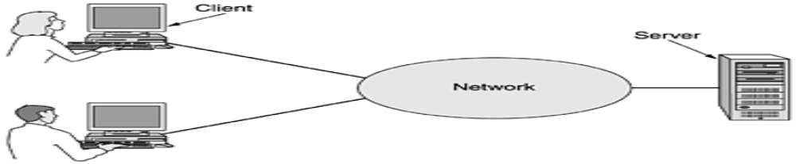

- This whole arrangement is called the client-server model. It is widely used and forms the basis of much network usage. It is applicable when the client and server are both in the same building (e.g., belong to the same company), but also when they are far apart.
- If we look at the client-server model in detail, we see that two processes are involved, one on the client machine and one on the server machine.
- Communication takes the form of the client process sending a message over the network to the server process.
- The client process then waits for a reply message. When the server process gets the request, it performs the requested work or looks up the requested data and sends back a reply.
Figure 1-2. The client-server model involves requests and replies
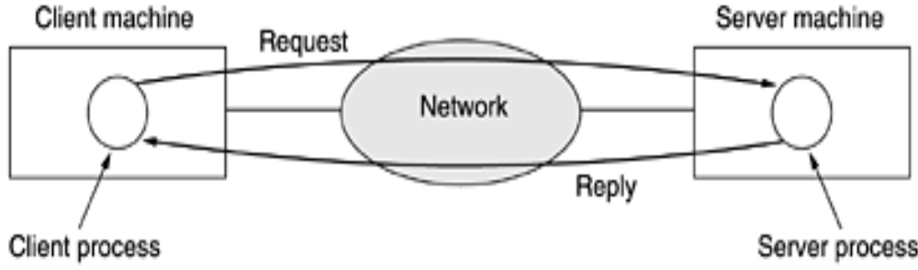

- A fourth goal that is starting to become more important is doing business with consumers over the Internet.
- Airlines, bookstores, and music vendors have discovered that many customers like the convenience of shopping from home.
- Consequently, many companies provide catalogs of their goods and services online and take orders on-line. This sector is expected to grow quickly in the future. It is called e-commerce (electronic commerce)
2. HOME APPLICATIONS:
Some of the more popular uses of the Internet for home users are as follows:

1. Access to remote information.
2. Person-to-person communication.
3. Interactive entertainment.
4. Electronic commerce.

Access to remote information:

- Access to remote information comes in many forms. It can be surfing the World Wide Web for information or just for fun. Information available includes the arts, business, cooking, government, health, history, hobbies, recreation, science, sports, travel, and many others.

- Many newspapers have gone on-line and can be personalized. For example, it is sometimes possible to tell a newspaper that you want everything about corrupt politicians, big fires, scandals involving celebrities.
Person-to-person communication:

- The second broad category of network use is person-to-person communication, basically the 21st century's answer to the 19th century's telephone.
- E-mail is already used on a daily basis by millions of people all over the world and its use is growing rapidly. It already routinely contains audio and video as well as text and pictures.
- Another type of person-to-person communication often goes by the name of peer-to-peer communication, to distinguish it from the client-server model.
- In this form, individuals who form a loose group can communicate with others in the group, as show in the fig below. Every person can, in principle, communicate with one or more other people; there is no fixed division into clients and servers.

Figure 1-3. In a peer-to-peer system there are no fixed clients and servers.
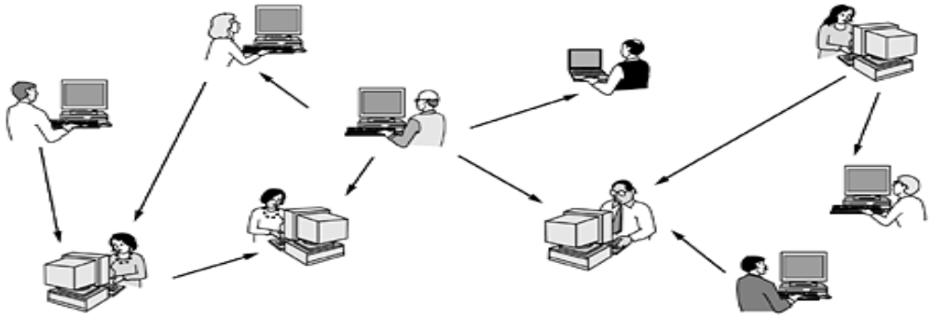
Interactive entertainment:

- Our third category is entertainment, which is a huge and growing industry. The killer application here (the one that may drive all the rest) is video on demand. Live television may also become interactive, with the audience participating in quiz shows, choosing among contestants, and so on.
Electronic commerce:

- Our fourth category is electronic commerce in the broadest sense of the term. Home shopping is already popular and enables users to inspect the on-line catalogs of thousands of companies. After the customer buys a product electronically but cannot figure out how to use it, on-line technical support may be consulted.

3. MOBILE USERS:

- Mobile computers, such as notebook computers and personal digital assistants (PDAs), are one of the fastest-growing segments of the computer industry. Many owners of these computers have desktop machines back at the office and want to be connected to their home base even when away from home or en route.
- Wireless networks are also important to the military. If you have to be able to fight a war anywhere on earth on short notice, counting on using the local networking infrastructure is probably not a good idea. It is better to bring your own. Although wireless networking and mobile computing are often related, they are not identical.

Figure 1-5. Combinations of wireless networks and mobile computing.

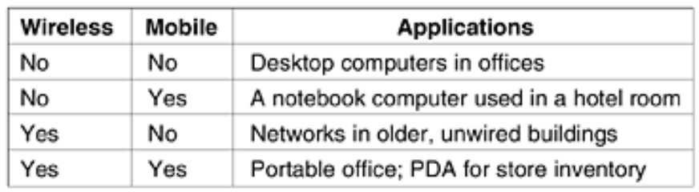

- A whole different application area for wireless networks is the expected merger of cell phones and PDAs into tiny wireless computers. A first attempt was tiny wireless PDAs that could display stripped-down Web pages on their even tinier screens.
SOCIAL ISSUES:
- The widespread introduction of networking has introduced new social, ethical, and political problems. People can exchange messages with like-minded individuals. As long as the subjects are restricted to technical topics or hobbies like gardening, not too many problems will arise.

- The trouble comes when newsgroups are set up on topics that people actually care about, like politics, religion, or sex. Views posted to such groups may be deeply offensive to some people.

- Some people take a live-and-let-live view, but others feel that posting certain material (e.g., attacks on particular countries or religions, child pornography, etc.) is simply unacceptable and must be censored. Were encrypted and authenticated, it would be harder to commit mischief. This technology is well established.

NETWORK HARDWARE
Broadly speaking, there are two types of transmission technology that are in widespread use. They are as follows:

1. Broadcast links.
2. Point-to-point links.

Broadcast networks have a single communication channel that is shared by all the machines on the network. Short messages, called packets in certain contexts, sent by any machine are received by all the others. An address field within the packet specifies the intended recipient. Upon receiving a packet, a machine checks the address field. If the packet is intended for the receiving machine, that machine processes the packet; if the packet is intended for some other machine, it is just ignored.

Broadcast systems generally also allow the possibility of addressing a packet to all destinations by using a special code in the address field. When a packet with this code is transmitted, it is received and processed by every machine on the network. This mode of operation is called broadcasting.

Some broadcast systems also support transmission to a subset of the machines, something known as multicasting. One possible scheme is to reserve one bit to indicate multicasting. The remaining n - 1 address bits can hold a group number. Each machine can ''subscribe'' to any or all of the groups. When a packet is sent to a certain group, it is delivered to all machines subscribing to that group.

In contrast, point-to-point networks consist of many connections between individual pairs of machines. To go from the source to the destination, a packet on this type of network may have to first visit one or more intermediate machines. Often multiple routes, of different lengths, are possible, so finding good ones is important in point-to-point networks. Point-to-point transmission with one sender and one receiver is sometimes called unicasting.
Figure 1-6. Classification of interconnected processors by scale.
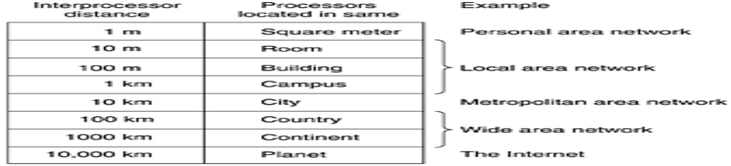

Local Area Networks:

- Local area networks, generally called LANs, are privately-owned networks within a single building or campus of up to a few kilometers in size.

- They are widely used to connect personal computers and workstations in company offices and factories to share resources (e.g., printers) and exchange information.

- LANs are distinguished from other kinds of networks by three characteristics:
(1) their size,
(2) their transmission technology, and
(3) their topology
.
- LANs are restricted in size, which means that the worst-case transmission time is bounded and known in advance. Knowing this bound makes it possible to use certain kinds of designs that would not otherwise be possible. It also simplifies network management.

- LANs may use a transmission technology consisting of a cable to which all the machines are attached, like the telephone company party lines once used in rural areas

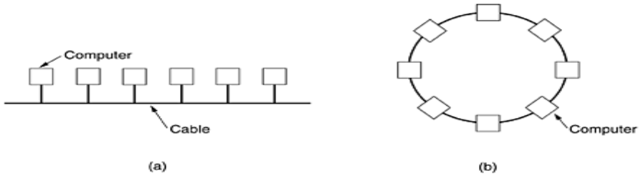
Figure . Two broadcast networks. (a) Bus. (b) Ring.

- A second type of broadcast system is the ring. In a ring, each bit propagates around on its own, not waiting for the rest of the packet to which it belongs. Typically, each bit circumnavigates the entire ring in the time it takes to transmit a few bits, often before the complete packet has even been transmitted.

Metropolitan Area Networks

A metropolitan area network, or MAN, covers a city. The best-known example of a MAN is the cable television network available in many cities. This system grew from earlier community antenna systems used in areas with poor over-the-air television reception. In these early systems, a large antenna was placed on top of a nearby hill and signal was then piped to the subscribers' houses.

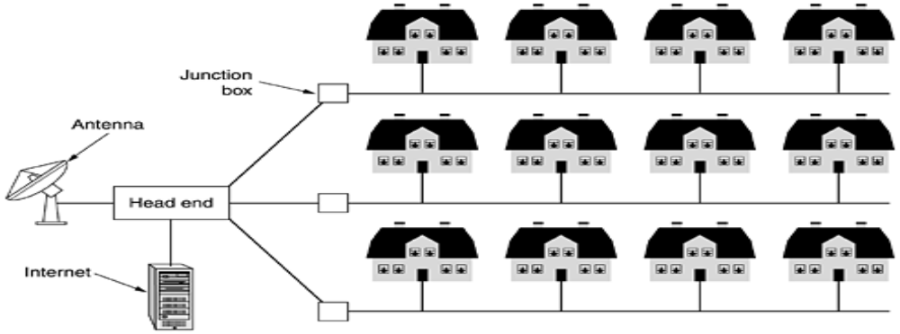

Figure. A metropolitan area network based on cable TV.

Wide Area Networks

A wide area network, or WAN, spans a large geographical area, often a country or continent. It contains a collection of machines intended for running user (i.e., application) programs. The hosts are connected by a communication subnet, or just subnet for short.
The hosts are owned by the customers (e.g., people's personal computers), whereas the communication subnet is typically owned and operated by a telephone company or Internet service provider. The job of the subnet is to carry messages from host to host, just as the telephone system carries words from speaker to listener.

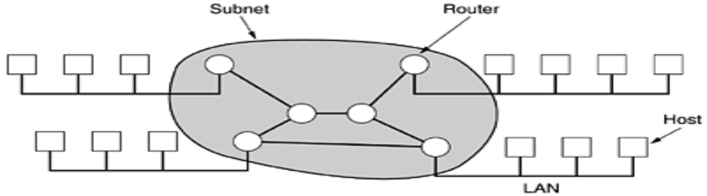

Figure. Relation between hosts on LANs and the subnet.

- A short comment about the term ''subnet'' is in order here. Originally, its only meaning was the collection of routers and communication lines that moved packets from the source node to the destination node.

- In most WANs, the network contains numerous transmission lines, each one connecting a pair of routers. If two routers that do not share a transmission line wish to communicate, they must do this indirectly, via other routers.

- When a packet is sent from one router to another via one or more intermediate routers, the packet is received at each intermediate router in its entirety, stored there until the required output line is free, and then forwarded. From source host to the destination host.

Figure 1-10. A stream of packets from sender to receiver:

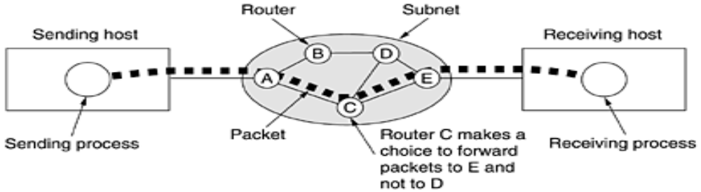

- In this figure, all the packets follow the route ACE, rather than ABDE or ACDE. In some networks all packets from a given message must follow the same route; in others each packet is routed separately. Of course, if ACE is the best route, all packets may be sent along it, even if each packet is individually routed.

- Routing decisions are made locally. When a packet arrives at router A, it is up to A to decide if this packet should be sent on the line to B or the line to C. How A makes that decision is called the routing algorithm. Many of them exist.

Wireless Networks:

Digital wireless communication is not a new idea. As early as 1901, the Italian physicist Guglielmo Marconi demonstrated a ship-to-shore wireless telegraph, using Morse code (dots and dashes are binary, after all). Modern digital wireless systems have better performance, but the basic idea is the same.
To a first approximation, wireless networks can be divided into three main categories:

1. System interconnection.
2. Wireless LANs.
3. Wireless WANs.

System interconnection is all about interconnecting the components of a computer using short-range radio. Almost every computer has a monitor, keyboard, mouse, and printer connected to the main unit by cables. Consequently, some companies got together to design a short-range wireless network called Bluetooth to connect these components without wires. Bluetooth also allows digital cameras, headsets, scanners, and other devices to connect to a computer by merely being brought within range. No cables, no driver installation, just put them down, turn them on, and they work. For many people, this ease of operation is a big plus.

In the simplest form, system interconnection networks use the master-slave paradigm of Fig. 1-11(a). The system unit is normally the master, talking to the mouse, keyboard, etc., as slaves. The master tells the slaves what addresses to use, when they can broadcast, how long they can transmit, what frequencies they can use, and so on.

Figure 1-11. (a) Bluetooth configuration. (b) Wireless LAN.

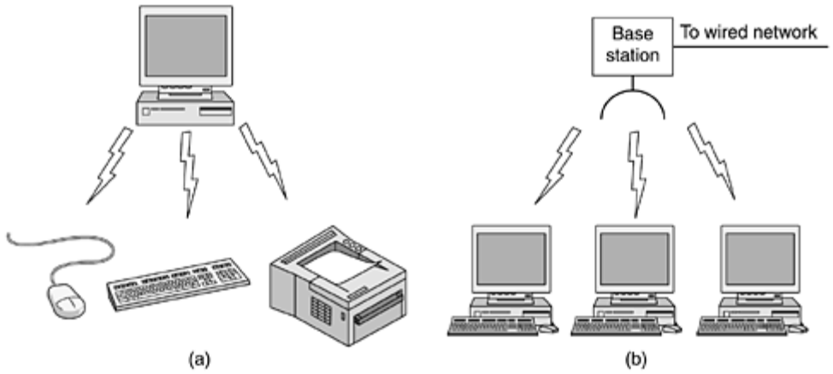

The next step up in wireless networking are the wireless LANs. These are systems in which every computer has a radio modem and antenna with which it can communicate with other systems. Often there is an antenna on the ceiling that the machines talk to, as shown in Fig. 1-11(b). However, if the systems are close enough, they can communicate directly with one another in a peer-to-peer configuration.

Wireless LANs are becoming increasingly common in small offices and homes, where installing Ethernet is considered too much trouble, as well as in older office buildings, company cafeterias, conference rooms, and other places. There is a standard for wireless LANs, called IEEE 802.11, which most systems implement and which is becoming very widespread.

The third kind of wireless network is used in wide area systems. The radio network used for cellular telephones is an example of a low-bandwidth wireless system. This system has already gone through three generations.
The first generation was analog and for voice only.
The second generation was digital and for voice only.
The third generation is digital and is for both voice and data.
In a certain sense, cellular wireless networks are like wireless LANs, except that the distances involved are much greater and the bit rates much lower. Wireless LANs can operate at rates up to about 50 Mbps over distances of tens of meters. Cellular systems operate below 1 Mbps, but the distance between the base station and the computer or telephone is measured in kilometers rather than in meters.

Figure 1-12. (a) Individual mobile computers. (b) A flying LAN.

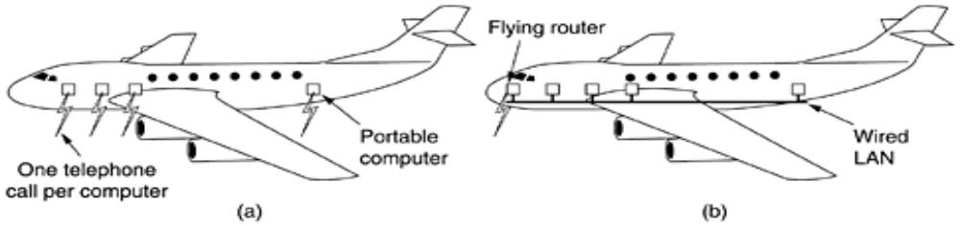

Home Networks

Home networking is on the horizon. The fundamental idea is that in the future most homes will be set up for networking. Every device in the home will be capable of communicating with every other device, and all of them will be accessible over the Internet. This is one of those visionary concepts that nobody asked for (like TV remote controls or mobile phones), but once they arrived nobody can imagine how they lived without them.
Many devices are capable of being networked. Some of the more obvious categories (with examples) are as follows:

1. Computers (desktop PC, notebook PC, PDA, shared peripherals).
2. Entertainment (TV, DVD, VCR, camcorder, camera, stereo, MP3).
3. Telecommunications (telephone, mobile telephone, intercom, fax).
4. Appliances (microwave, refrigerator, clock, furnace, airco, lights).
5. Telemetry (utility meter, smoke/burglar alarm, thermostat, babycam).

Internetworks:

Many networks exist in the world, often with different hardware and software. People connected to one network often want to communicate with people attached to a different one. The fulfillment of this desire requires that different, and frequently incompatible networks, be connected, sometimes by means of machines called gateways to make the connection and provide the necessary translation, both in terms of hardware and software. A collection of interconnected networks is called an internetwork or internet. These terms will be used in a generic sense, in contrast to the worldwide Internet which we will always capitalize.

Subnets, networks, and internetworks are often confused. Subnet makes the most sense in the context of a wide area network, where it refers to the collection of routers and communication lines owned by the network operator. As an analogy, the telephone system consists of telephone switching offices connected to one another by high-speed lines, and to houses and businesses by low-speed lines.

An internetwork is formed when distinct networks are interconnected. In our view, connecting a LAN and a WAN or connecting two LANs forms an internetwork, but there is little agreement in the industry over terminology in this area. One rule of thumb is that if different organizations paid to construct different parts of the network and each maintains its part, we have an internetwork rather than a single network.

NETWORK SOFTWARE

The first computer networks were designed with the hardware as the main concern and the software as an afterthought. This strategy no longer works. Network software is now highly structured.

Protocol Hierarchies:

To reduce their design complexity, most networks are organized as a stack of layers or levels, each one built upon the one below it. The number of layers, the name of each layer, the contents of each layer, and the function of each layer differ from network to network. The purpose of each layer is to offer certain services to the higher layers, shielding those layers from the details of how the offered services are actually implemented. In a sense, each layer is a kind of virtual machine, offering certain services to the layer above it.

A five-layer network is illustrated in Fig. 1-13. The entities comprising the corresponding layers on different machines are called peers. The peers may be processes, hardware devices, or even human beings. In other words, it is the peers that communicate by using the protocol.

A set of layers and protocols is called network architecture. The specification of an architecture must contain enough information to allow an implementer to write the program or build the hardware for each layer so that it will correctly obey the appropriate protocol.

An analogy may help explain the idea of multilayer communication. Imagine two philosophers (peer processes in layer 3), one of whom speaks Urdu and English and one of whom speaks Chinese and French. Since they have no common language, they each engage a translator (peer processes at layer 2), each of whom in turn contacts a secretary (peer processes in layer 1). Philosopher 1 wishes to convey his affection for oryctolagus cuniculus to his peer. To do so, he passes a message (in English) across the 2/3 interface to his translator, saying ''I like rabbits,'' as illustrated in Fig. 1-14.

Figure 1-14. The philosopher-translator-secretary architecture.

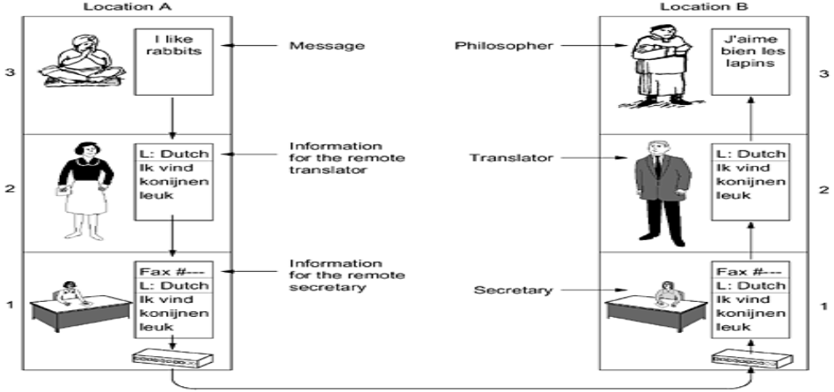

Figure 1-15. Example information flow supporting virtual communication in layer 5.

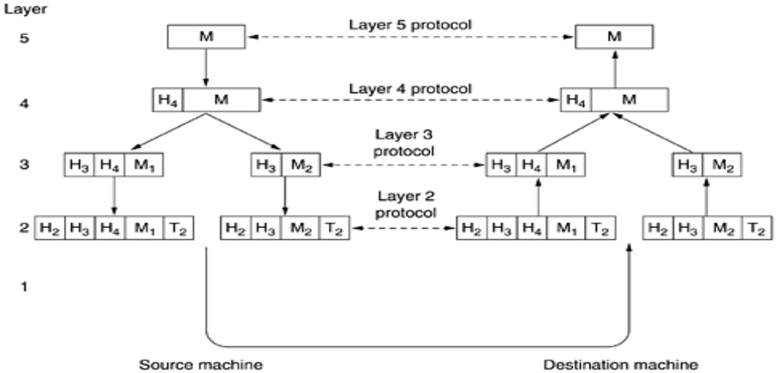

In many networks, there is no limit to the size of messages transmitted in the layer 4 protocol, but there is nearly always a limit imposed by the layer 3 protocol. Consequently, layer 3 must break up the incoming messages into smaller units, packets, prepending a layer 3 header to each packet. In this example, M is split into two parts, M₁ and M₂.

Layer 3 decides which of the outgoing lines to use and passes the packets to layer 2. Layer 2 adds not only a header to each piece, but also a trailer, and gives the resulting unit to layer 1 for physical transmission. At the receiving machine the message moves upward, from layer to layer, with headers being stripped off as it progresses. None of the headers for layers below n are passed up to layer n.

The important thing to understand about Fig. 1-15 is the relation between the virtual and actual communication and the difference between protocols and interfaces.

The peer process abstraction is crucial to all network design. Using it, the unmanageable task of designing the complete network can be broken into several smaller, manageable design problems, namely, the design of the individual layers.

Design Issues for the Layers:

Every layer needs a mechanism for identifying senders and receivers. Since a network normally has many computers, some of which have multiple processes, a means is needed for a process on one machine to specify with whom it wants to talk. As a consequence of having multiple destinations, some form of addressing is needed in order to specify a specific destination.

Another set of design decisions concerns the rules for data transfer. In some systems, data only travel in one direction; in others, data can go both ways. The protocol must also determine how many logical channels the connection corresponds to and what their priorities are. Many networks provide at least two logical channels per connection, one for normal data and one for urgent data.

Error control is an important issue because physical communication circuits are not perfect. Many error-detecting and error-correcting codes are known, but both ends of the connection must agree on which one is being used. In addition, the receiver must have some way of telling the sender which messages have been correctly received and which has not.

Not all communication channels preserve the order of messages sent on them. To deal with a possible loss of sequencing, the protocol must make explicit provision for the receiver to allow the pieces to be reassembled properly. An obvious solution is to number the pieces, but this solution still leaves open the question of what should be done with pieces that arrive out of order.

Another problem that must be solved at several levels is the inability of all processes to accept arbitrarily long messages. This property leads to mechanisms for disassembling, transmitting, and then reassembling messages. A related issue is the problem of what to do when processes insist on transmitting data in units that are so small that sending each one separately is inefficient.

When it is inconvenient or expensive to set up a separate connection for each pair of communicating processes, the underlying layer may decide to use the same connection for multiple, unrelated conversations.

Connection-Oriented and Connectionless Services:

Layers can offer two different types of service to the layers above them: connection-oriented and connectionless.
Connection-oriented service is modeled after the telephone system. To talk to someone, you pick up the phone, dial the number, talk, and then hang up. Similarly, to use a connection-oriented network service, the service user first establishes a connection, uses the connection, and then releases the connection.
In contrast, connectionless service is modeled after the postal system. Each message (letter) carries the full destination address, and each one is routed through the system independent of all the others. Normally, when two messages are sent to the same destination, the first one sent will be the first one to arrive. However, it is possible that the first one sent can be delayed so that the second one arrives first.

Service Primitives:
A service is formally specified by a set of primitives (operations) available to a user process to access the service. These primitives tell the service to perform some action or report on an action taken by a peer entity.
If the protocol stack is located in the operating system, as it often is, the primitives are normally system calls. These calls cause a trap to kernel mode, which then turns control of the machine over to the operating system to send the necessary packets.

The set of primitives available depends on the nature of the service being provided. The primitives for connection-oriented service are different from those of connectionless service.

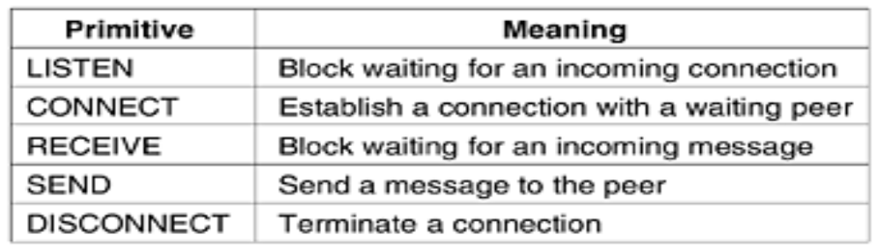

REFERENCE MODELS

There are two major approaches:
1. The seven-layer OSI/ISO model – Open Systems Interconnection, currently maintained by the International Organization for Standards.

2. The five-layer TCP/IP model – Transmission Control Protocol/Internet Protocol.

THE OSI REFERENCE MODEL
The OSI model (minus the physical medium) is shown in Fig. 1-20. This model is based on a proposal developed by the International Standards Organization (ISO) as a first step toward international standardization of the protocols used in the various layers (Day and Zimmermann, 1983).
It was revised in 1995 (Day, 1995). The model is called the ISO OSI (Open Systems Interconnection) Reference Model because it deals with connecting open systems—that is, systems that are open for communication with other systems. We will just call it the OSI model for short.

Figure 1-20. The OSI reference model

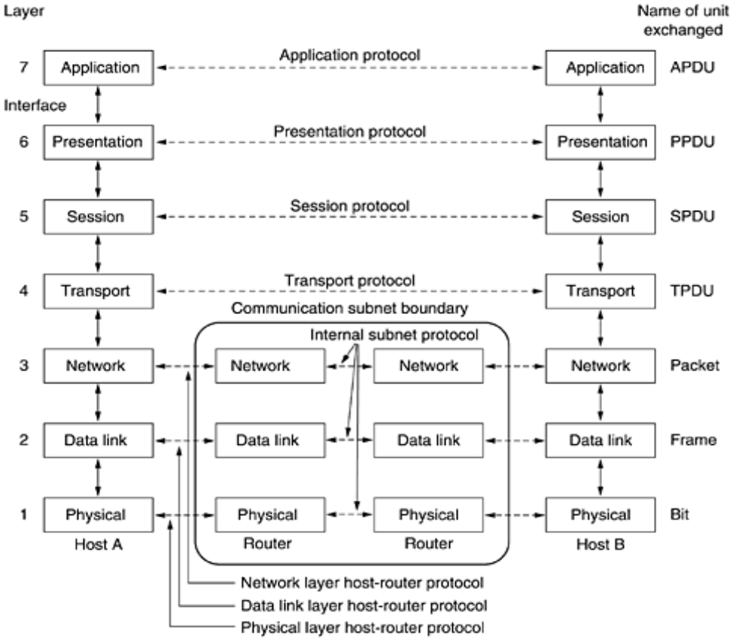

The Physical Layer
- The physical layer is concerned with transmitting raw bits over a communication channel.
- How the initial connection is established and how it is torn down when both sides are finished, and how many pins the network connector has and what each pin is used for.
- The design issues have to do with making sure that when one side sends a 1 bit, it is received by the other side as a 1 bit, not as a 0 bit.
- The design issues here largely deal with mechanical, electrical, and timing interfaces, and the physical transmission medium, which lies below the physical layer.

The Data Link Layer
- The main task of the data link layer is to transform a raw transmission facility into a line that appears free of undetected transmission errors to the network layer.
- It accomplishes this task by having the sender break up the input data into data frames (typically a few hundred or a few thousand bytes) and transmits the frames sequentially.
- If the service is reliable, the receiver confirms correct receipt of each frame by sending back an acknowledgement frame.
- Another issue that arises in the data link layer (and most of the higher layers as well) is how to keep a fast transmitter from drowning a slow receiver in data.
- Some traffic regulation mechanism is often needed to let the transmitter know how much buffer space the receiver has at the moment. Frequently, this flow regulation and the error handling are integrated.
- Broadcast networks have an additional issue in the data link layer: how to control access to the shared channel. A special sublayer of the data link layer, the medium access control sublayer, deals with this problem.

The Network Layer
- The network layer controls the operation of the subnet. A key design issue is determining how packets are routed from source to destination. Routes can be based on static tables that are ''wired into'' the network and rarely changed.
- They can also be determined at the start of each conversation, for example, a terminal session (e.g., a login to a remote machine). Finally, they can be highly dynamic, being determined anew for each packet, to reflect the current network load.
- If too many packets are present in the subnet at the same time, they will get in one another's way, forming bottlenecks. The control of such congestion also belongs to the network layer. More generally, the quality of service provided (delay, transit time, jitter, etc.) is also a network layer issue.

The Transport Layer
- The basic function of the transport layer is to accept data from above, split it up into smaller units if need be, pass these to the network layer, and ensure that the pieces all arrive correctly at the other end. Furthermore, all this must be done efficiently and in a way that isolates the upper layers from the inevitable changes in the hardware technology.
- The transport layer also determines what type of service to provide to the session layer, and, ultimately, to the users of the network.
- The most popular type of transport connection is an error-free point-to-point channel that delivers messages or bytes in the order in which they were sent. However, other possible kinds of transport service are the transporting of isolated messages, with no guarantee about the order of delivery, and the broadcasting of messages to multiple destinations.
- The type of service is determined when the connection is established. (As an aside, an error-free channel is impossible to achieve; what people really mean by this term is that the error rate is low enough to ignore in practice.)
- A program on the source machine carries on a conversation with a similar program on the destination machine, using the message headers and control messages.
- In the lower layers, the protocols are between each machine and its immediate neighbors, and not between the ultimate source and destination machines, which may be separated by many routers.
The Session Layer
- The session layer allows users on different machines to establish sessions between them. Sessions offer various services, including dialog control (keeping track of whose turn it is to transmit), token management (preventing two parties from attempting the same critical operation at the same time), and synchronization (checkpointing long transmissions to allow them to continue from where they were after a crash).

The Presentation Layer
- Unlike lower layers, which are mostly concerned with moving bits around, the presentation layer is concerned with the syntax and semantics of the information transmitted.
- In order to make it possible for computers with different data representations to communicate, the data structures to be exchanged can be defined in an abstract way, along with a standard encoding to be used ''on the wire.''
- The presentation layer manages these abstract data structures and allows higher-level data structures (e.g., banking records), to be defined and exchanged.

The Application Layer
- The application layer contains a variety of protocols that are commonly needed by users. One widely-used application protocol is HTTP (Hyper Text Transfer Protocol), which is the basis for the World Wide Web.
- When a browser wants a Web page, it sends the name of the page it wants to the server using HTTP. The server then sends the page back. Other application protocols are used for file transfer, electronic mail, and network news.

THE TCP/IP REFERENCE MODEL
Let us now turn from the OSI reference model to the reference model used in the grandparent of all wide area computer networks, the ARPANET, and its successor, the worldwide Internet. Although we will give a brief history of the ARPANET later, it is useful to mention a few key aspects of it now. The ARPANET was a research network sponsored by the DoD (U.S. Department of Defense). It eventually connected hundreds of universities and government installations, using leased telephone lines. When satellite and radio networks were added later, the existing protocols had trouble interworking with them, so a new reference architecture was needed. Thus, the ability to connect multiple networks in a seamless way was one of the major design goals from the very beginning. This architecture later became known as the TCP/IP Reference Model, after its two primary protocols. It was first defined in (Cerf and Kahn, 1974). A later perspective is given in (Leiner et al., 1985). The design philosophy behind the model is discussed in (Clark, 1988).
Given the DoD's worry that some of its precious hosts, routers, and internetwork gateways might get blown to pieces at a moment's notice, another major goal was that the network be able to survive loss of subnet hardware, with existing conversations not being broken off. In other words, DoD wanted connections to remain intact as long as the source and destination machines were functioning, even if some of the machines or transmission lines in between were suddenly put out of operation. Furthermore, a flexible architecture was needed since applications with divergent requirements were envisioned, ranging from transferring files to real-time speech transmission.

The Internet Layer
All these requirements led to the choice of a packet-switching network based on a connectionless internetwork layer. This layer, called the internet layer.
Its job is to permit hosts to inject packets into any network and have them travel independently to the destination (potentially on a different network). They may even arrive in a different order than they were sent, in which case it is the job of higher layers to rearrange them, if in-order delivery is desired. Note that ''internet'' is used here in a generic sense, even though this layer is present in the Internet.
The analogy here is with the (snail) mail system. A person can drop a sequence of international letters into a mail box in one country, and with a little luck, most of them will be delivered to the correct address in the destination country. Probably the letters will travel through one or more international mail gateways along the way, but this is transparent to the users. Furthermore, that each country (i.e., each network) has its own stamps, preferred envelope sizes, and delivery rules is hidden from the users.
The internet layer defines an official packet format and protocol called IP (Internet Protocol). The job of the internet layer is to deliver IP packets where they are supposed to go.
Packet routing is clearly the major issue here, as is avoiding congestion. For these reasons, it is reasonable to say that the TCP/IP internet layer is similar in functionality to the OSI network layer. Figure 1-21 shows this correspondence.

Figure 1-21. The TCP/IP reference model.
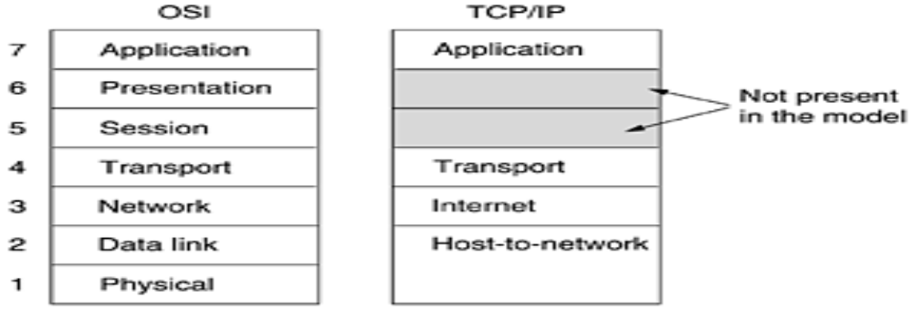

The Transport Layer
The layer above the internet layer in the TCP/IP model is now usually called the transport layer. It is designed to allow peer entities on the source and destination hosts to carry on a conversation, just as in the OSI transport layer.
Two end-to-end transport protocols have been defined here.
The first one, TCP (Transmission Control Protocol), is a reliable connection-oriented protocol that allows a byte stream originating on one machine to be delivered without error on any other machine in the internet.
It fragments the incoming byte stream into discrete messages and passes each one on to the internet layer. At the destination, the receiving TCP process reassembles the received messages into the output stream. TCP also handles flow control to make sure a fast sender cannot swamp a slow receiver with more messages than it can handle.
The second protocol in this layer, UDP (User Datagram Protocol), is an unreliable, connectionless protocol for applications that do not want TCP's sequencing or flow control and wish to provide their own.
It is also widely used for one-shot, client-server-type request-reply queries and applications in which prompt delivery is more important than accurate delivery, such as transmitting speech or video. The relation of IP, TCP, and UDP is shown in Fig. 1-22. Since the model was developed, IP has been implemented on many other networks.

Figure 1-22. Protocols and networks in the TCP/IP model initially.
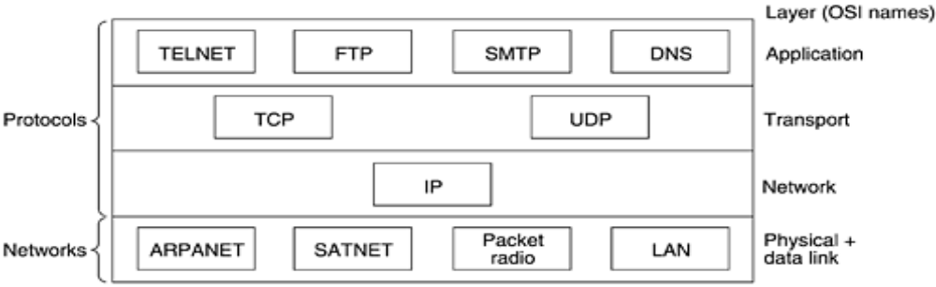

The Application Layer
The TCP/IP model does not have session or presentation layers. No need for them was perceived, so they were not included. Experience with the OSI model has proven this view correct: they are of little use to most applications.
On top of the transport layer is the application layer. It contains all the higher-level protocols. The early ones included virtual terminal (TELNET), file transfer (FTP), and electronic mail (SMTP), as shown in Fig. 1-22. The virtual terminal protocol allows a user on one machine to log onto a distant machine and work there.
The file transfer protocol provides a way to move data efficiently from one machine to another. Electronic mail was originally just a kind of file transfer, but later a specialized protocol (SMTP) was developed for it.
Many other protocols have been added to these over the years: the Domain Name System (DNS) for mapping host names onto their network addresses, NNTP, the protocol for moving USENET news articles around, and HTTP, the protocol for fetching pages on the World Wide Web, and many others.

The Host-to-Network Layer
Below the internet layer is a great void. The TCP/IP reference model does not really say much about what happens here, except to point out that the host has to connect to the network using some protocol so it can send IP packets to it. This protocol is not defined and varies from host to host and network to network. Books and papers about the TCP/IP model rarely discuss it.

EXAMPLE NETWORKS
The subject of computer networking covers many different kinds of networks, large and small, well known and less well known. They have different goals, scales, and technologies. In the following sections, we will look at some examples, to get an idea of the variety one finds in the area of computer networking.
We will start with the Internet, probably the best known network, and look at its history, evolution, and technology. Then we will consider ATM, which is often used within the core of large (telephone) networks. Technically, it is quite different from the Internet, contrasting nicely with it. Next we will introduce Ethernet, the dominant local area network. Finally, we will look at IEEE 802.11, the standard for wireless LANs.

The Internet
The Internet is not a network at all, but a vast collection of different networks that use certain common protocols and provide certain common services. It is an unusual system in that it was not planned by anyone and is not controlled by anyone. To better understand it, let us start from the beginning and see how it has developed and why. For a wonderful history of the Internet, John Naughton's (2000) book is highly recommended. It is one of those rare books that is not only fun to read, but also has 20 pages of ibid.'s and op. cit.'s for the serious historian. Some of the material below is based on this book.
Of course, countless technical books have been written about the Internet and its protocols as well. For more information, see, for example, (Maufer, 1999).

The ARPANET
The story begins in the late 1950s. At the height of the Cold War, the DoD wanted a command-and-control network that could survive a nuclear war. At that time, all military communications used the public telephone network, which was considered vulnerable. The reason for this belief can be gleaned from Fig. 1-25(a). Here the black dots represent telephone switching offices, each of which was connected to thousands of telephones. These switching offices were, in turn, connected to higher-level switching offices (toll offices), to form a national hierarchy with only a small amount of redundancy. The vulnerability of the system was that the destruction of a few key toll offices could fragment the system into many isolated islands.

Figure 1-25. (a) Structure of the telephone system. (b) Baran's proposed distributed switching system.
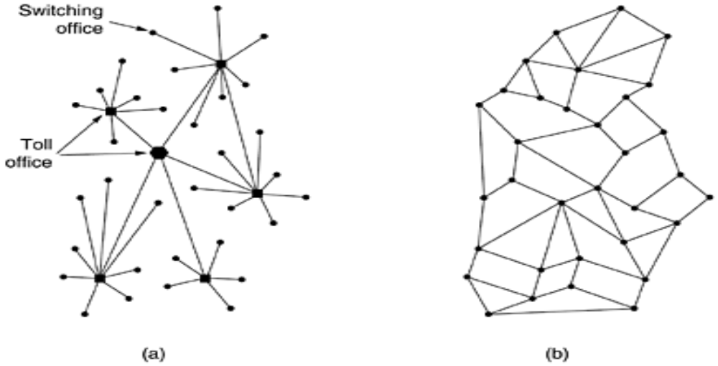
Around 1960, the DoD awarded a contract to the RAND Corporation to find a solution. One of its employees, Paul Baran, came up with the highly distributed and fault-tolerant design of Fig. 1-25(b). Since the paths between any two switching offices were now much longer than analog signals could travel without distortion, Baran proposed using digital packet-switching technology throughout the system. Baran wrote several reports for the DoD describing his ideas in detail. Officials at the Pentagon liked the concept and asked AT&T, then the U.S. national telephone monopoly, to build a prototype. AT&T dismissed Baran's ideas out of hand. The biggest and richest corporation in the world was not about to allow some young whippersnapper tell it how to build a telephone system. They said Baran's network could not be built and the idea was killed.
Several years went by and still the DoD did not have a better command-and-control system. To understand what happened next, we have to go back to October 1957, when the Soviet Union beat the U.S. into space with the launch of the first artificial satellite, Sputnik. When President Eisenhower tried to find out who was asleep at the switch, he was appalled to find the Army, Navy, and Air Force squabbling over the Pentagon's research budget. His immediate response was to create a single defense research organization, ARPA, the Advanced Research Projects Agency. ARPA had no scientists or laboratories; in fact, it had nothing more than an office and a small (by Pentagon standards) budget. It did its work by issuing grants and contracts to universities and companies whose ideas looked promising to it.
For the first few years, ARPA tried to figure out what its mission should be, but in 1967, the attention of ARPA's then director, Larry Roberts, turned to networking. He contacted various experts to decide what to do. One of them, Wesley Clark, suggested building a packet-switched subnet, giving each host its own router, as illustrated in Fig. 1-10.
After some initial skepticism, Roberts bought the idea and presented a somewhat vague paper about it at the ACM SIGOPS Symposium on Operating System Principles held in Gatlinburg, Tennessee in late 1967 (Roberts, 1967). Much to Roberts' surprise, another paper at the conference described a similar system that had not only been designed but actually implemented under the direction of Donald Davies at the National Physical Laboratory in England. The NPL system was not a national system (it just connected several computers on the NPL campus), but it demonstrated that packet switching could be made to work. Furthermore, it cited Baran's now discarded earlier work. Roberts came away from Gatlinburg determined to build what later became known as the ARPANET.
The subnet would consist of minicomputers called IMPs (Interface Message Processors) connected by 56-kbps transmission lines. For high reliability, each IMP would be connected to at least two other IMPs. The subnet was to be a datagram subnet, so if some lines and IMPs were destroyed, messages could be automatically rerouted along alternative paths.
Each node of the network was to consist of an IMP and a host, in the same room, connected by a short wire. A host could send messages of up to 8063 bits to its IMP, which would then break these up into packets of at most 1008 bits and forward them independently toward the destination. Each packet was received in its entirety before being forwarded, so the subnet was the first electronic store-and-forward packet-switching network.
ARPA then put out a tender for building the subnet. Twelve companies bid for it. After evaluating all the proposals, ARPA selected BBN, a consulting firm in Cambridge, Massachusetts, and in December 1968, awarded it a contract to build the subnet and write the subnet software. BBN chose to use specially modified Honeywell DDP-316 minicomputers with 12K 16-bit words of core memory as the IMPs. The IMPs did not have disks, since moving parts were considered unreliable. The IMPs were interconnected by 56-kbps lines leased from telephone companies. Although 56 kbps is now the choice of teenagers who cannot afford ADSL or cable, it was then the best money could buy.
The software was split into two parts: subnet and host. The subnet software consisted of the IMP end of the host-IMP connection, the IMP-IMP protocol, and a source IMP to destination IMP protocol designed to improve reliability. The original ARPANET design is shown in Fig. 1-26.

Figure 1-26. The original ARPANET design.
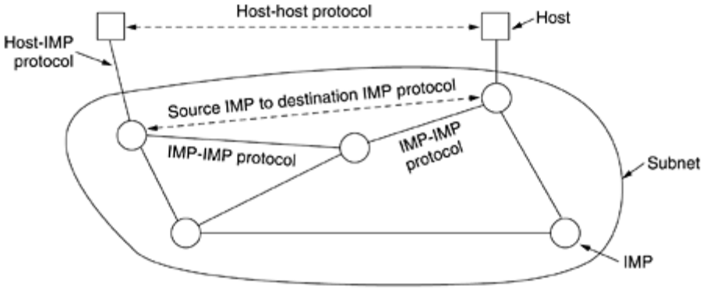
Outside the subnet, software was also needed, namely, the host end of the host-IMP connection, the host-host protocol, and the application software. It soon became clear that BBN felt that when it had accepted a message on a host-IMP wire and placed it on the host-IMP wire at the destination, its job was done.
Roberts had a problem: the hosts needed software too. To deal with it, he convened a meeting of network researchers, mostly graduate students, at Snowbird, Utah, in the summer of 1969. The graduate students expected some network expert to explain the grand design of the network and its software to them and then to assign each of them the job of writing part of it. They were astounded when there was no network expert and no grand design. They had to figure out what to do on their own.
Nevertheless, somehow an experimental network went on the air in December 1969 with four nodes: at UCLA, UCSB, SRI, and the University of Utah. These four were chosen because all had a large number of ARPA contracts, and all had different and completely incompatible host computers (just to make it more fun). The network grew quickly as more IMPs were delivered and installed; it soon spanned the United States. Figure 1-27 shows how rapidly the ARPANET grew in the first 3 years.

Figure 1-27. Growth of the ARPANET. (a) December 1969. (b) July 1970. (c) March 1971. (d) April 1972. (e) September 1972.
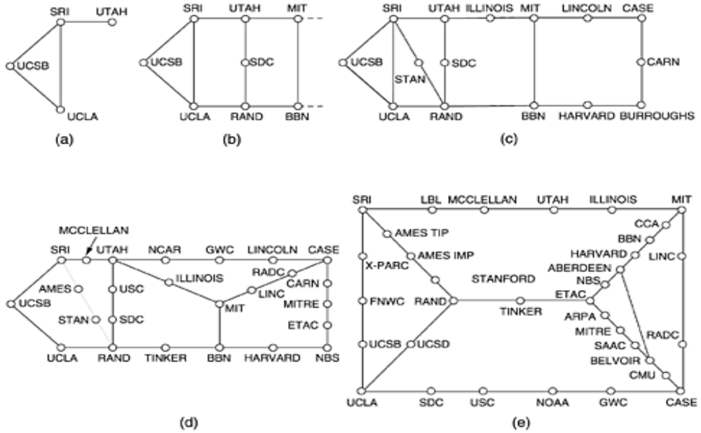
In addition to helping the fledgling ARPANET grow, ARPA also funded research on the use of satellite networks and mobile packet radio networks. In one now famous demonstration, a truck driving around in California used the packet radio network to send messages to SRI, which were then forwarded over the ARPANET to the East Coast, where they were shipped to University College in London over the satellite network. This allowed a researcher in the truck to use a computer in London while driving around in California.
This experiment also demonstrated that the existing ARPANET protocols were not suitable for running over multiple networks. This observation led to more research on protocols, culminating with the invention of the TCP/IP model and protocols (Cerf and Kahn, 1974). TCP/IP was specifically designed to handle communication over internetworks, something becoming increasingly important as more and more networks were being hooked up to the ARPANET.
To encourage adoption of these new protocols, ARPA awarded several contracts to BBN and the University of California at Berkeley to integrate them into Berkeley UNIX. Researchers at Berkeley developed a convenient program interface to the network (sockets) and wrote many application, utility, and management programs to make networking easier.
The timing was perfect. Many universities had just acquired a second or third VAX computer and a LAN to connect them, but they had no networking software. When 4.2BSD came along, with TCP/IP, sockets, and many network utilities, the complete package was adopted immediately. Furthermore, with TCP/IP, it was easy for the LANs to connect to the ARPANET, and many did.
During the 1980s, additional networks, especially LANs, were connected to the ARPANET. As the scale increased, finding hosts became increasingly expensive, so DNS (Domain Name System) was created to organize machines into domains and map host names onto IP addresses. Since then, DNS has become a generalized, distributed database system for storing a variety of information related to naming. We will study it in detail in Chap. 7.

NSFNET
By the late 1970s, NSF (the U.S. National Science Foundation) saw the enormous impact the ARPANET was having on university research, allowing scientists across the country to share data and collaborate on research projects. However, to get on the ARPANET, a university had to have a research contract with the DoD, which many did not have. NSF's response was to design a successor to the ARPANET that would be open to all university research groups. To have something concrete to start with, NSF decided to build a backbone network to connect its six supercomputer centers, in San Diego, Boulder, Champaign, Pittsburgh, Ithaca, and Princeton. Each supercomputer was given a little brother, consisting of an LSI-11 microcomputer called a fuzzball. The fuzzballs were connected with 56-kbps leased lines and formed the subnet, the same hardware technology as the ARPANET used. The software technology was different however: the fuzzballs spoke TCP/IP right from the start, making it the first TCP/IP WAN.
NSF also funded some (eventually about 20) regional networks that connected to the backbone to allow users at thousands of universities, research labs, libraries, and museums to access any of the supercomputers and to communicate with one another. The complete network, including the backbone and the regional networks, was called NSFNET. It connected to the ARPANET through a link between an IMP and a fuzzball in the Carnegie-Mellon machine room. The first NSFNET backbone is illustrated in Fig. 1-28.

Figure 1-28. The NSFNET backbone in 1988.
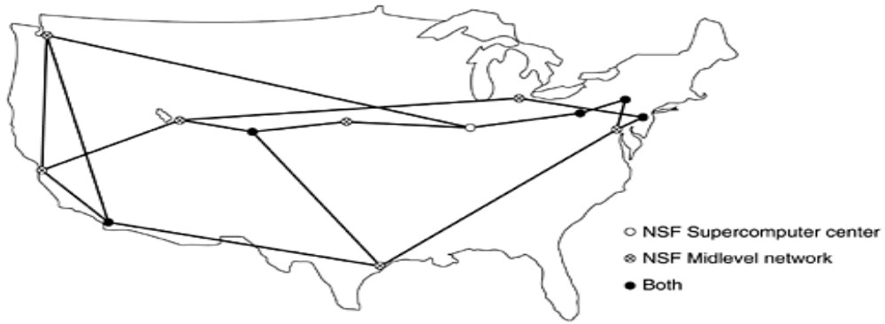
NSFNET was an instantaneous success and was overloaded from the word go. NSF immediately began planning its successor and awarded a contract to the Michigan-based MERIT consortium to run it. Fiber optic channels at 448 kbps were leased from MCI (since merged with WorldCom) to provide the version 2 backbone. IBM PC-RTs were used as routers. This, too, was soon overwhelmed, and by 1990, the second backbone was upgraded to 1.5 Mbps.
As growth continued, NSF realized that the government could not continue financing networking forever. Furthermore, commercial organizations wanted to join but were forbidden by NSF's charter from using networks NSF paid for. Consequently, NSF encouraged MERIT, MCI, and IBM to form a nonprofit corporation, ANS (Advanced Networks and Services), as the first step along the road to commercialization. In 1990, ANS took over NSFNET and upgraded the 1.5-Mbps links to 45 Mbps to form ANSNET. This network operated for 5 years and was then sold to America Online. But by then, various companies were offering commercial IP service and it was clear the government should now get out of the networking business.
To ease the transition and make sure every regional network could communicate with every other regional network, NSF awarded contracts to four different network operators to establish a NAP (Network Access Point). These operators were PacBell (San Francisco), Ameritech (Chicago), MFS (Washington, D.C.), and Sprint (New York City, where for NAP purposes, Pennsauken, New Jersey counts as New York City). Every network operator that wanted to provide backbone service to the NSF regional networks had to connect to all the NAPs.
This arrangement meant that a packet originating on any regional network had a choice of backbone carriers to get from its NAP to the destination's NAP. Consequently, the backbone carriers were forced to compete for the regional networks' business on the basis of service and price, which was the idea, of course. As a result, the concept of a single default backbone was replaced by a commercially-driven competitive infrastructure. Many people like to criticize the Federal Government for not being innovative, but in the area of networking, it was DoD and NSF that created the infrastructure that formed the basis for the Internet and then handed it over to industry to operate.
During the 1990s, many other countries and regions also built national research networks, often patterned on the ARPANET and NSFNET. These included EuropaNET and EBONE in Europe, which started out with 2-Mbps lines and then upgraded to 34-Mbps lines. Eventually, the network infrastructure in Europe was handed over to industry as well.

Connection-Oriented Networks: X.25, Frame Relay, and ATM
Since the beginning of networking, a war has been going on between the people who support connectionless (i.e., datagram) subnets and the people who support connection-oriented subnets. The main proponents of the connectionless subnets come from the ARPANET/Internet community. Remember that DoD's original desire in funding and building the ARPANET was to have a network that would continue functioning even after multiple direct hits by nuclear weapons wiped out numerous routers and transmission lines. Thus, fault tolerance was high on their priority list; billing customers was not. This approach led to a connectionless design in which every packet is routed independently of every other packet. As a consequence, if some routers go down during a session, no harm is done as long as the system can reconfigure itself dynamically so that subsequent packets can find some route to the destination, even if it is different from that which previous packets used.
The connection-oriented camp comes from the world of telephone companies. In the telephone system, a caller must dial the called party's number and wait for a connection before talking or sending data. This connection setup establishes a route through the telephone system that is maintained until the call is terminated. All words or packets follow the same route. If a line or switch on the path goes down, the call is aborted. This property is precisely what the DoD did not like about it.
Why do the telephone companies like it then? There are two reasons:
- Quality of service.
- Billing.
By setting up a connection in advance, the subnet can reserve resources such as buffer space and router CPU capacity. If an attempt is made to set up a call and insufficient resources are available, the call is rejected and the caller gets a kind of busy signal. In this way, once a connection has been set up, the connection will get good service. With a connectionless network, if too many packets arrive at the same router at the same moment, the router will choke and probably lose packets. The sender will eventually notice this and resend them, but the quality of service will be jerky and unsuitable for audio or video unless the network is very lightly loaded. Needless to say, providing adequate audio quality is something telephone companies care about very much, hence their preference for connections.
The second reason the telephone companies like connection-oriented service is that they are accustomed to charging for connect time. When you make a long distance call (or even a local call outside North America) you are charged by the minute. When networks came around, they just automatically gravitated toward a model in which charging by the minute was easy to do. If you have to set up a connection before sending data, that is when the billing clock starts running. If there is no connection, they cannot charge for it.
Ironically, maintaining billing records is very expensive. If a telephone company were to adopt a flat monthly rate with unlimited calling and no billing or record keeping, it would probably save a huge amount of money, despite the increased calling this policy would generate. Political, regulatory, and other factors weigh against doing this, however. Interestingly enough, flat rate service exists in other sectors. For example, cable TV is billed at a flat rate per month, no matter how many programs you watch. It could have been designed with pay-per-view as the basic concept, but it was not, due in part to the expense of billing (and given the quality of most television, the embarrassment factor cannot be totally discounted either). Also, many theme parks charge a daily admission fee for unlimited rides, in contrast to traveling carnivals, which charge by the ride.
That said, it should come as no surprise that all networks designed by the telephone industry have had connection-oriented subnets. What is perhaps surprising, is that the Internet is also drifting in that direction, in order to provide a better quality of service for audio and video, a subject we will return to in Chap. 5. But now let us examine some connection-oriented networks.

X.25 and Frame Relay
Our first example of a connection-oriented network is X.25, which was the first public data network. It was deployed in the 1970s at a time when telephone service was a monopoly everywhere and the telephone company in each country expected there to be one data network per country—theirs. To use X.25, a computer first established a connection to the remote computer, that is, placed a telephone call. This connection was given a connection number to be used in data transfer packets (because multiple connections could be open at the same time). Data packets were very simple, consisting of a 3-byte header and up to 128 bytes of data. The header consisted of a 12-bit connection number, a packet sequence number, an acknowledgement number, and a few miscellaneous bits. X.25 networks operated for about a decade with mixed success.
In the 1980s, the X.25 networks were largely replaced by a new kind of network called frame relay. The essence of frame relay is that it is a connection-oriented network with no error control and no flow control. Because it was connection-oriented, packets were delivered in order (if they were delivered at all). The properties of in-order delivery, no error control, and no flow control make frame relay akin to a wide area LAN. Its most important application is interconnecting LANs at multiple company offices. Frame relay enjoyed a modest success and is still in use in places today.

Asynchronous Transfer Mode
Yet another, and far more important, connection-oriented network is ATM (Asynchronous Transfer Mode). The reason for the somewhat strange name is that in the telephone system, most transmission is synchronous (closely tied to a clock), and ATM is not.
ATM was designed in the early 1990s and launched amid truly incredible hype (Ginsburg, 1996; Goralski, 1995; Ibe, 1997; Kim et al., 1994; and Stallings, 2000). ATM was going to solve all the world's networking and telecommunications problems by merging voice, data, cable television, telex, telegraph, carrier pigeon, tin cans connected by strings, tom-toms, smoke signals, and everything else into a single integrated system that could do everything for everyone. It did not happen. In large part, the problems were similar to those we described earlier concerning OSI, that is, bad timing, technology, implementation, and politics. Having just beaten back the telephone companies in round 1, many in the Internet community saw ATM as Internet versus the Telcos: the Sequel. But it really was not, and this time around even diehard datagram fanatics were aware that the Internet's quality of service left a lot to be desired. To make a long story short, ATM was much more successful than OSI, and it is now widely used deep within the telephone system, often for moving IP packets. Because it is now mostly used by carriers for internal transport, users are often unaware of its existence, but it is definitely alive and well.

ATM Virtual Circuits
Since ATM networks are connection-oriented, sending data requires first sending a packet to set up the connection. As the setup packet wends its way through the subnet, all the routers on the path make an entry in their internal tables noting the existence of the connection and reserving whatever resources are needed for it. Connections are often called virtual circuits, in analogy with the physical circuits used within the telephone system. Most ATM networks also support permanent virtual circuits, which are permanent connections between two (distant) hosts. They are similar to leased lines in the telephone world. Each connection, temporary or permanent, has a unique connection identifier. A virtual circuit is illustrated in Fig. 1-30.

Figure 1-30. A virtual circuit.
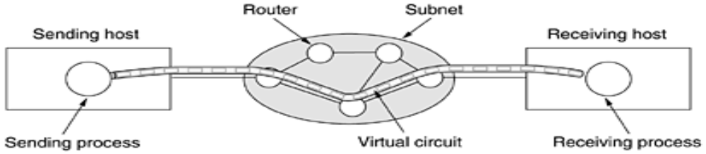
Once a connection has been established, either side can begin transmitting data. The basic idea behind ATM is to transmit all information in small, fixed-size packets called cells. The cells are 53 bytes long, of which 5 bytes are header and 48 bytes are payload, as shown in Fig. 1-31. Part of the header is the connection identifier, so the sending and receiving hosts and all the intermediate routers can tell which cells belong to which connections. This information allows each router to know how to route each incoming cell. Cell routing is done in hardware, at high speed. In fact, the main argument for having fixed-size cells is that it is easy to build hardware routers to handle short, fixed-length cells. Variable-length IP packets have to be routed by software, which is a slower process. Another plus of ATM is that the hardware can be set up to copy one incoming cell to multiple output lines, a property that is required for handling a television program that is being broadcast to many receivers. Finally, small cells do not block any line for very long, which makes guaranteeing quality of service easier.

Figure 1-31. An ATM cell.
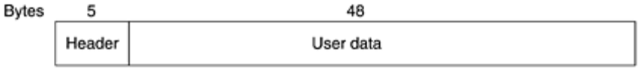
All cells follow the same route to the destination. Cell delivery is not guaranteed, but their order is. If cells 1 and 2 are sent in that order, then if both arrive, they will arrive in that order, never first 2 then 1. But either or both of them can be lost along the way. It is up to higher protocol levels to recover from lost cells. Note that although this guarantee is not perfect, it is better than what the Internet provides. There packets can not only be lost, but delivered out of order as well. ATM, in contrast, guarantees never to deliver cells out of order.
ATM networks are organized like traditional WANs, with lines and switches (routers). The most common speeds for ATM networks are 155 Mbps and 622 Mbps, although higher speeds are also supported. The 155-Mbps speed was chosen because this is about what is needed to transmit high definition television. The exact choice of 155.52 Mbps was made for compatibility with AT&T's SONET transmission system, something we will study in Chap. 2. The 622 Mbps speed was chosen so that four 155-Mbps channels could be sent over it.

The ATM Reference Model
ATM has its own reference model, different from the OSI model and also different from the TCP/IP model. This model is shown in Fig. 1-32. It consists of three layers, the physical, ATM, and ATM adaptation layers, plus whatever users want to put on top of that.

Figure 1-32. The ATM reference model.
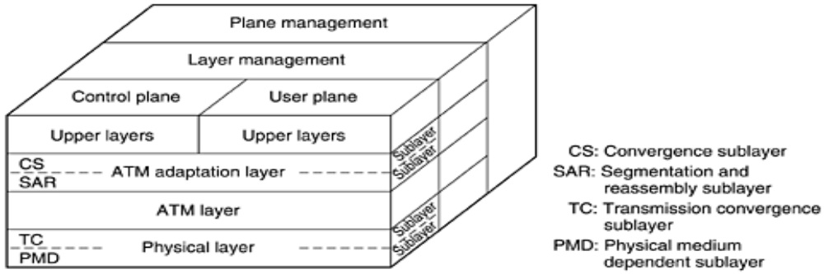
The physical layer deals with the physical medium: voltages, bit timing, and various other issues. ATM does not prescribe a particular set of rules but instead says that ATM cells can be sent on a wire or fiber by themselves, but they can also be packaged inside the payload of other carrier systems. In other words, ATM has been designed to be independent of the transmission medium.
The ATM layer deals with cells and cell transport. It defines the layout of a cell and tells what the header fields mean. It also deals with establishment and release of virtual circuits. Congestion control is also located here.
Because most applications do not want to work directly with cells (although some may), a layer above the ATM layer has been defined to allow users to send packets larger than a cell. The ATM interface segments these packets, transmits the cells individually, and reassembles them at the other end. This layer is the AAL (ATM Adaptation Layer).
Unlike the earlier two-dimensional reference models, the ATM model is defined as being three-dimensional, as shown in Fig. 1-32. The user plane deals with data transport, flow control, error correction, and other user functions. In contrast, the control plane is concerned with connection management. The layer and plane management functions relate to resource management and interlayer coordination.
The physical and AAL layers are each divided into two sublayers, one at the bottom that does the work and a convergence sublayer on top that provides the proper interface to the layer above it. The functions of the layers and sublayers are given in Fig. 1-33.

Figure 1-33. The ATM layers and sublayers, and their functions.
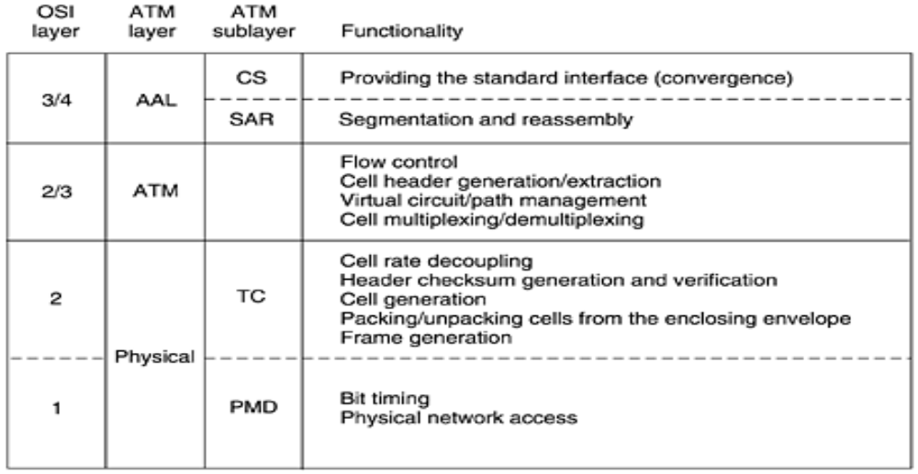
The PMD (Physical Medium Dependent) sub layer interfaces to the actual cable. It moves the bits on and off and handles the bit timing. For different carriers and cables, this layer will be different.
The other sub layer of the physical layer is the TC (Transmission Convergence) sub layer. When cells are transmitted, the TC layer sends them as a string of bits to the PMD layer. Doing this is easy. At the other end, the TC sub layer gets a pure incoming bit stream from the PMD sub layer. Its job is to convert this bit stream into a cell stream for the ATM layer. It handles all the issues related to telling where cells begin and end in the bit stream. In the ATM model, this functionality is in the physical layer. In the OSI model and in pretty much all other networks, the job of framing, that is, turning a raw bit stream into a sequence of frames or cells, is the data link layer's task.
As we mentioned earlier, the ATM layer manages cells, including their generation and transport. Most of the interesting aspects of ATM are located here. It is a mixture of the OSI data link and network layers; it is not split into sub layers.
The AAL layer is split into a SAR (Segmentation And Reassembly) sublayer and a CS (Convergence Sublayer). The lower sublayer breaks up packets into cells on the transmission side and puts them back together again at the destination. The upper sublayer makes it possible to have ATM systems offer different kinds of services to different applications (e.g., file transfer and video on demand have different requirements concerning error handling, timing, etc.).
As it is probably mostly downhill for ATM from now on, we will not discuss it further in this book. Nevertheless, since it has a substantial installed base, it will probably be around for at least a few more years. For more information about ATM, see (Dobrowski and Grise, 2001; and Gadecki and Heckart, 1997).

Ethernet
Both the Internet and ATM were designed for wide area networking. However, many companies, universities, and other organizations have large numbers of computers that must be connected. This need gave rise to the local area network. In this section we will say a little bit about the most popular LAN, Ethernet.
The story starts out in pristine Hawaii in the early 1970s. In this case, ''pristine'' can be interpreted as ''not having a working telephone system.'' While not being interrupted by the phone all day long makes life more pleasant for vacationers, it did not make life more pleasant for researcher Norman Abramson and his colleagues at the University of Hawaii who were trying to connect users on remote islands to the main computer in Honolulu. Stringing their own cables under the Pacific Ocean was not in the cards, so they looked for a different solution.
The one they found was short-range radios. Each user terminal was equipped with a small radio having two frequencies: upstream (to the central computer) and downstream (from the central computer). When the user wanted to contact the computer, it just transmitted a packet containing the data in the upstream channel. If no one else was transmitting at that instant, the packet probably got through and was acknowledged on the downstream channel. If there was contention for the upstream channel, the terminal noticed the lack of acknowledgement and tried again. Since there was only one sender on the downstream channel (the central computer), there were never collisions there. This system, called ALOHANET, worked fairly well under conditions of low traffic but bogged down badly when the upstream traffic was heavy.
About the same time, a student named Bob Metcalfe got his bachelor's degree at M.I.T. and then moved up the river to get his Ph.D. at Harvard. During his studies, he was exposed to Abramson's work. He became so interested in it that after graduating from Harvard, he decided to spend the summer in Hawaii working with Abramson before starting work at Xerox PARC (Palo Alto Research Center). When he got to PARC, he saw that the researchers there had designed and built what would later be called personal computers. But the machines were isolated. Using his knowledge of Abramson's work, he, together with his colleague David Boggs, designed and implemented the first local area network (Metcalfe and Boggs, 1976).
They called the system Ethernet after the luminiferous ether, through which electromagnetic radiation was once thought to propagate. (When the 19th century British physicist James Clerk Maxwell discovered that electromagnetic radiation could be described by a wave equation, scientists assumed that space must be filled with some ethereal medium in which the radiation was propagating. Only after the famous Michelson-Morley experiment in 1887 did physicists discover that electromagnetic radiation could propagate in a vacuum.)
The transmission medium here was not a vacuum, but a thick coaxial cable (the ether) up to 2.5 km long (with repeaters every 500 meters). Up to 256 machines could be attached to the system via transceivers screwed onto the cable. A cable with multiple machines attached to it in parallel is called a multidrop cable. The system ran at 2.94 Mbps. A sketch of its architecture is given in Fig. 1-34. Ethernet had a major improvement over ALOHANET: before transmitting, a computer first listened to the cable to see if someone else was already transmitting. If so, the computer held back until the current transmission finished. Doing so avoided interfering with existing transmissions, giving a much higher efficiency. ALOHANET did not work like this because it was impossible for a terminal on one island to sense the transmission of a terminal on a distant island. With a single cable, this problem does not exist.

Figure 1-34. Architecture of the original Ethernet.
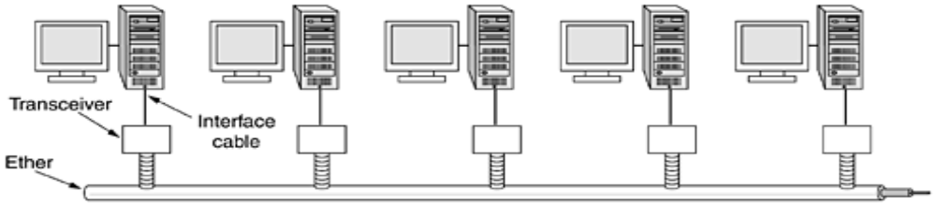
Despite the computer listening before transmitting, a problem still arises: what happens if two or more computers all wait until the current transmission completes and then all start at once? The solution is to have each computer listen during its own transmission and if it detects interference, jam the ether to alert all senders. Then back off and wait a random time before retrying. If a second collision happens, the random waiting time is doubled, and so on, to spread out the competing transmissions and give one of them a chance to go first.
The Xerox Ethernet was so successful that DEC, Intel, and Xerox drew up a standard in 1978 for a 10-Mbps Ethernet, called the DIX standard. With two minor changes, the DIX standard became the IEEE 802.3 standard in 1983.
Unfortunately for Xerox, it already had a history of making seminal inventions (such as the personal computer) and then failing to commercialize on them, a story told in Fumbling the Future (Smith and Alexander, 1988). When Xerox showed little interest in doing anything with Ethernet other than helping standardize it, Metcalfe formed his own company, 3Com, to sell Ethernet adapters for PCs. It has sold over 100 million of them.
Ethernet continued to develop and is still developing. New versions at 100 Mbps, 1000 Mbps, and still higher have come out. Also the cabling has improved, and switching and other features have been added. We will discuss Ethernet in detail in Chap. 4.
In passing, it is worth mentioning that Ethernet (IEEE 802.3) is not the only LAN standard. The committee also standardized a token bus (802.4) and a token ring (802.5). The need for three more-or-less incompatible standards has little to do with technology and everything to do with politics. At the time of standardization, General Motors was pushing a LAN in which the topology was the same as Ethernet (a linear cable) but computers took turns in transmitting by passing a short packet called a token from computer to computer. A computer could only send if it possessed the token, thus avoiding collisions. General Motors announced that this scheme was essential for manufacturing cars and was not prepared to budge from this position. This announcement notwithstanding, 802.4 has basically vanished from sight.
Similarly, IBM had its own favorite: its proprietary token ring. The token was passed around the ring and whichever computer held the token was allowed to transmit before putting the token back on the ring. Unlike 802.4, this scheme, standardized as 802.5, is still in use at some IBM sites, but virtually nowhere outside of IBM sites. However, work is progressing on a gigabit version (802.5v), but it seems unlikely that it will ever catch up with Ethernet. In short, there was a war between Ethernet, token bus, and token ring, and Ethernet won, mostly because it was there first and the challengers were not as good.

Wireless LANs: 802.11
Almost as soon as notebook computers appeared, many people had a dream of walking into an office and magically having their notebook computer be connected to the Internet. Consequently, various groups began working on ways to accomplish this goal. The most practical approach is to equip both the office and the notebook computers with short-range radio transmitters and receivers to allow them to communicate. This work rapidly led to wireless LANs being marketed by a variety of companies.
The trouble was that no two of them were compatible. This proliferation of standards meant that a computer equipped with a brand X radio would not work in a room equipped with a brand Y base station. Finally, the industry decided that a wireless LAN standard might be a good idea, so the IEEE committee that standardized the wired LANs was given the task of drawing up a wireless LAN standard. The standard it came up with was named 802.11. A common slang name for it is WiFi. It is an important standard and deserves respect, so we will call it by its proper name, 802.11.
The proposed standard had to work in two modes:
- In the presence of a base station.
- In the absence of a base station.
In the former case, all communication was to go through the base station, called an access point in 802.11 terminology. In the latter case, the computers would just send to one another directly. This mode is now sometimes called ad hoc networking. A typical example is two or more people sitting down together in a room not equipped with a wireless LAN and having their computers just communicate directly. The two modes are illustrated in Fig. 1-35.

Figure 1-35. (a) Wireless networking with a base station. (b) Ad hoc networking.
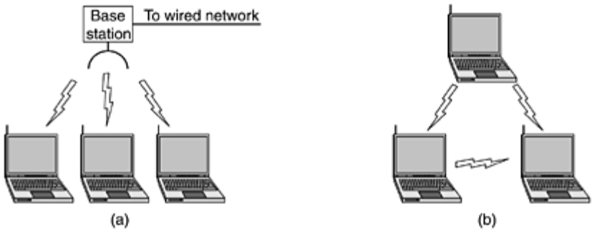
The first decision was the easiest: what to call it. All the other LAN standards had numbers like 802.1, 802.2, 802.3, up to 802.10, so the wireless LAN standard was dubbed 802.11. The rest was harder.
In particular, some of the many challenges that had to be met were: finding a suitable frequency band that was available, preferably worldwide; dealing with the fact that radio signals have a finite range; ensuring that users' privacy was maintained; taking limited battery life into account; worrying about human safety (do radio waves cause cancer?); understanding the implications of computer mobility; and finally, building a system with enough bandwidth to be economically viable.
At the time the standardization process started (mid-1990s), Ethernet had already come to dominate local area networking, so the committee decided to make 802.11 compatible with Ethernet above the data link layer. In particular, it should be possible to send an IP packet over the wireless LAN the same way a wired computer sent an IP packet over Ethernet. Nevertheless, in the physical and data link layers, several inherent differences with Ethernet exist and had to be dealt with by the standard.
First, a computer on Ethernet always listens to the ether before transmitting. Only if the ether is idle does the computer begin transmitting. With wireless LANs, that idea does not work so well. To see why, examine Fig. 1-36. Suppose that computer A is transmitting to computer B, but the radio range of A's transmitter is too short to reach computer C. If C wants to transmit to B it can listen to the ether before starting, but the fact that it does not hear anything does not mean that its transmission will succeed. The 802.11 standard had to solve this problem.

Figure 1-36. The range of a single radio may not cover the entire system.
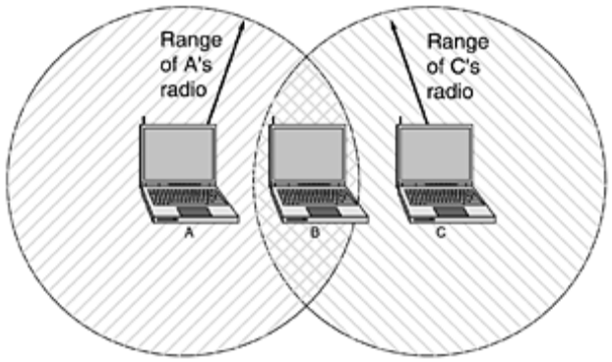
The second problem that had to be solved is that a radio signal can be reflected off solid objects, so it may be received multiple times (along multiple paths). This interference results in what is called multipath fading.
The third problem is that a great deal of software is not aware of mobility. For example, many word processors have a list of printers that users can choose from to print a file. When the computer on which the word processor runs is taken into a new environment, the built-in list of printers becomes invalid.
The fourth problem is that if a notebook computer is moved away from the ceiling-mounted base station it is using and into the range of a different base station, some way of handing it off is needed. Although this problem occurs with cellular telephones, it does not occur with Ethernet and needed to be solved. In particular, the network envisioned consists of multiple cells, each with its own base station, but with the base stations connected by Ethernet, as shown in Fig. 1-37. From the outside, the entire system should look like a single Ethernet. The connection between the 802.11 system and the outside world is called a portal.

Figure 1-37. A multicell 802.11 network.
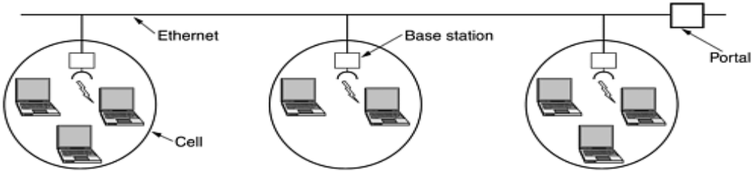
After some work, the committee came up with a standard in 1997 that addressed these and other concerns. The wireless LAN it described ran at either 1 Mbps or 2 Mbps. Almost immediately, people complained that it was too slow, so work began on faster standards. A split developed within the committee, resulting in two new standards in 1999. The 802.11a standard uses a wider frequency band and runs at speeds up to 54 Mbps. The 802.11b standard uses the same frequency band as 802.11, but uses a different modulation technique to achieve 11 Mbps. Some people see this as psychologically important since 11 Mbps is faster than the original wired Ethernet. It is likely that the original 1-Mbps 802.11 will die off quickly, but it is not yet clear which of the new standards will win out.
To make matters even more complicated than they already were, the 802 committee has come up with yet another variant, 802.11g, which uses the modulation technique of 802.11a but the frequency band of 802.11b. We will come back to 802.11 in detail in Chap. 4.
That 802.11 is going to cause a revolution in computing and Internet access is now beyond any doubt. Airports, train stations, hotels, shopping malls, and universities are rapidly installing it. Even upscale coffee shops are installing 802.11 so that the assembled yuppies can surf the Web while drinking their lattes. It is likely that 802.11 will do to the Internet what notebook computers did to computing: make it mobile.

TRANSMISSION MEDIA

The purpose of the physical layer is to transport a raw bit stream from one machine to another. Various physical media can be used for the actual transmission.
Each one has its own niche in terms of bandwidth, delay, cost, and ease of installation and maintenance. Media are roughly grouped into guided media, such as copper wire and fiber optics, and unguided media, such as radio and lasers through the air. We will look at all of these in the following sections.

Magnetic Media
One of the most common ways to transport data from one computer to another is to write them onto magnetic tape or removable media (e.g., recordable DVDs), physically transport the tape or disks to the destination machine, and read them back in again. Although this method is not as sophisticated as using a geosynchronous communication satellite, it is often more cost effective, especially for applications in which high bandwidth or cost per bit transported is the key factor.
A simple calculation will make this point clear.
- An industry standard Ultrium tape can hold 200 gigabytes.
- A box 60 x 60 x 60 cm can hold about 1000 of these tapes, for a total capacity of 200 terabytes, or 1600 terabits (1.6 petabits).
- A box of tapes can be delivered anywhere in the United States in 24 hours by Federal Express and other companies.
- The effective bandwidth of this transmission is 1600 terabits/86,400 sec, or 19 Gbps. If the destination is only an hour away by road, the bandwidth is increased to over 400 Gbps. No computer network can even approach this.
For a bank with many gigabytes of data to be backed up daily on a second machine (so the bank can continue to function even in the face of a major flood or earthquake), it is likely that no other transmission technology can even begin to approach magnetic tape for performance. Of course, networks are getting faster, but tape densities are increasing, too.
If we now look at cost, we get a similar picture.
- The cost of an Ultrium tape is around $40 when bought in bulk.
- A tape can be reused at least ten times, so the tape cost is maybe $4000 per box per usage. Add to this another $1000 for shipping (probably much less), and we have a cost of roughly $5000 to ship 200 TB.
- This amounts to shipping a gigabyte for under 3 cents. No network can beat that. The moral of the story is:
Never underestimate the bandwidth of a station wagon full of tapes hurtling down the highway

Twisted Pair

Characteristics
- The bandwidth characteristics of magnetic tape are excellent, the delay characteristics are poor. Transmission time is measured in minutes or hours, not milliseconds.
- For many applications an on-line connection is needed. One of the oldest and still most common transmission media is twisted pair.
- A twisted pair consists of two insulated copper wires, typically about 1 mm thick.
- The wires are twisted together in a helical form, just like a DNA molecule. Twisting is done because two parallel wires constitute a fine antenna. When the wires are twisted, the waves from different twists cancel out, so the wire radiates less effectively.
The most common application of the twisted pair is the telephone system. Nearly all telephones are connected to the telephone company (telco) office by a twisted pair. Twisted pairs can run several kilometers without amplification, but for longer distances, repeaters are needed.
When many twisted pairs run in parallel for a substantial distance, such as all the wires coming from an apartment building to the telephone company office, they are bundled together and encased in a protective sheath. The pairs in these bundles would interfere with one another if it were not for the twisting. In parts of the world where telephone lines run on poles above ground, it is common to see bundles several centimeters in diameter.
Twisted pairs can be used for transmitting either analog or digital signals. The bandwidth depends on the thickness of the wire and the distance traveled, but several megabits/sec can be achieved for a few kilometers in many cases. Due to their adequate performance and low cost, twisted pairs are widely used and are likely to remain so for years to come.
Twisted pair cabling comes in several varieties, two of which are important for computer networks. Category 3 twisted pairs consist of two insulated wires gently twisted together. Four such pairs are typically grouped in a plastic sheath to protect the wires and keep them together. Prior to about 1988, most office buildings had one category 3 cable running from a central wiring closet on each floor into each office. This scheme allowed up to four regular telephones or two multiline telephones in each office to connect to the telephone company equipment in the wiring closet.
Starting around 1988, the more advanced category 5 twisted pairs were introduced. They are similar to category 3 pairs, but with more twists per centimeter, which results in less crosstalk and a better-quality signal over longer distances, making them more suitable for high-speed computer communication. Up-and-coming categories are 6 and 7, which are capable of handling signals with bandwidths of 250 MHz and 600 MHz, respectively (versus a mere 16 MHz and 100 MHz for categories 3 and 5, respectively).
All of these wiring types are often referred to as UTP (Unshielded Twisted Pair), to contrast them with the bulky, expensive, shielded twisted pair cables IBM introduced in the early 1980s, but which have not proven popular outside of IBM installations. Twisted pair cabling is illustrated in Fig. 2-3.

Figure 2-3. (a) Category 3 UTP. (b) Category 5 UTP.

Coaxial Cable
Another common transmission medium is the coaxial cable (known to its many friends as just ''coax'' and pronounced ''co-ax''). It has better shielding than twisted pairs, so it can span longer distances at higher speeds.
Two kinds of coaxial cable are widely used. One kind, 50-ohm cable, is commonly used when it is intended for digital transmission from the start. The other kind, 75-ohm cable, is commonly used for analog transmission and cable television but is becoming more important with the advent of Internet over cable. This distinction is based on historical, rather than technical, factors (e.g., early dipole antennas had an impedance of 300 ohms, and it was easy to use existing 4:1 impedance matching transformers).
A coaxial cable consists of a stiff copper wire as the core, surrounded by an insulating material. The insulator is encased by a cylindrical conductor, often as a closely-woven braided mesh. The outer conductor is covered in a protective plastic sheath. A cutaway view of a coaxial cable is shown in Fig. 2-4.

Figure 2-4. A coaxial cable.
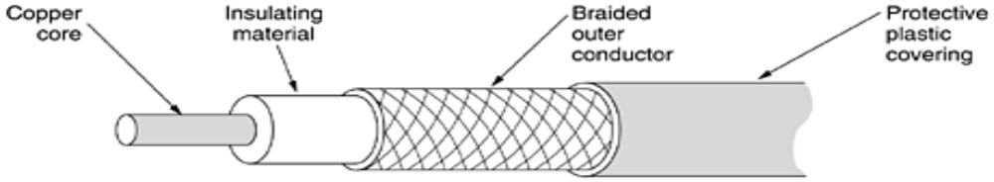
The construction and shielding of the coaxial cable give it a good combination of high bandwidth and excellent noise immunity. The bandwidth possible depends on the cable quality, length, and signal-to-noise ratio of the data signal.
Modern cables have a bandwidth of close to 1 GHz. Coaxial cables used to be widely used within the telephone system for long-distance lines but have now largely been replaced by fiber optics on long-haul routes. Coax is still widely used for cable television and metropolitan area networks, however.

Fiber Optics
Many people in the computer industry take enormous pride in how fast computer technology is improving. The original (1981) IBM PC ran at a clock speed of 4.77 MHz. Twenty years later, PCs could run at 2 GHz, a gain of a factor of 20 per decade. Not too bad.
In the same period, wide area data communication went from 56 kbps (the ARPANET) to 1 Gbps (modern optical communication), a gain of more than a factor of 125 per decade, while at the same time the error rate went from 10⁻⁵ per bit to almost zero.
Furthermore, single CPUs are beginning to approach physical limits, such as speed of light and heat dissipation problems. In contrast, with current fiber technology, the achievable bandwidth is certainly in excess of 50,000 Gbps (50 Tbps) and many people are looking very hard for better technologies and materials. The current practical signaling limit of about 10 Gbps is due to our inability to convert between electrical and optical signals any faster, although in the laboratory, 100 Gbps has been achieved on a single fiber.
In the race between computing and communication, communication won. The full implications of essentially infinite bandwidth (although not at zero cost) have not yet sunk in to a generation of computer scientists and engineers taught to think in terms of the low Nyquist and Shannon limits imposed by copper wire. The new conventional wisdom should be that all computers are hopelessly slow and that networks should try to avoid computation at all costs, no matter how much bandwidth that wastes. In this section we will study fiber optics to see how that transmission technology works.
An optical transmission system has three key components: the light source, the transmission medium, and the detector. Conventionally, a pulse of light indicates a 1 bit and the absence of light indicates a 0 bit. The transmission medium is an ultra-thin fiber of glass. The detector generates an electrical pulse when light falls on it. By attaching a light source to one end of an optical fiber and a detector to the other, we have a unidirectional data transmission system that accepts an electrical signal, converts and transmits it by light pulses, and then reconverts the output to an electrical signal at the receiving end.
This transmission system would leak light and be useless in practice except for an interesting principle of physics. When a light ray passes from one medium to another, for example, from fused silica to air, the ray is refracted (bent) at the silica/air boundary, as shown in Fig. 2-5(a). Here we see a light ray incident on the boundary at an angle a₁ emerging at an angle b₁. The amount of refraction depends on the properties of the two media (in particular, their indices of refraction). For angles of incidence above a certain critical value, the light is refracted back into the silica; none of it escapes into the air. Thus, a light ray incident at or above the critical angle is trapped inside the fiber, as shown in Fig. 2-5(b), and can propagate for many kilometers with virtually no loss.

Figure 2-5. (a) Three examples of a light ray from inside a silica fiber impinging on the air/silica boundary at different angles. (b) Light trapped by total internal reflection.
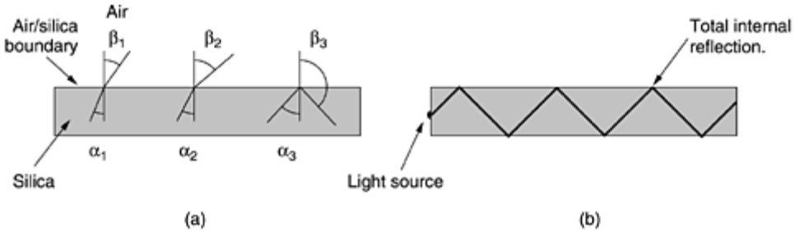
The sketch of Fig. 2-5(b) shows only one trapped ray, but since any light ray incident on the boundary above the critical angle will be reflected internally, many different rays will be bouncing around at different angles. Each ray is said to have a different mode, so a fiber having this property is called a multimode fiber.
However, if the fiber's diameter is reduced to a few wavelengths of light, the fiber acts like a wave guide, and the light can propagate only in a straight line, without bouncing, yielding a single-mode fiber. Single-mode fibers are more expensive but are widely used for longer distances. Currently available single-mode fibers can transmit data at 50 Gbps for 100 km without amplification. Even higher data rates have been achieved in the laboratory for shorter distances.

Transmission of Light through Fiber
Optical fibers are made of glass, which, in turn, is made from sand, an inexpensive raw material available in unlimited amounts. Glassmaking was known to the ancient Egyptians, but their glass had to be no more than 1 mm thick or the light could not shine through. Glass transparent enough to be useful for windows was developed during the Renaissance. The glass used for modern optical fibers is so transparent that if the oceans were full of it instead of water, the seabed would be as visible from the surface as the ground is from an airplane on a clear day.
The attenuation of light through glass depends on the wavelength of the light (as well as on some physical properties of the glass). For the kind of glass used in fibers, the attenuation is shown in Fig. 2-6 in decibels per linear kilometer of fiber. The attenuation in decibels is given by the formula

Figure 2-6. Attenuation of light through fiber in the infrared region.
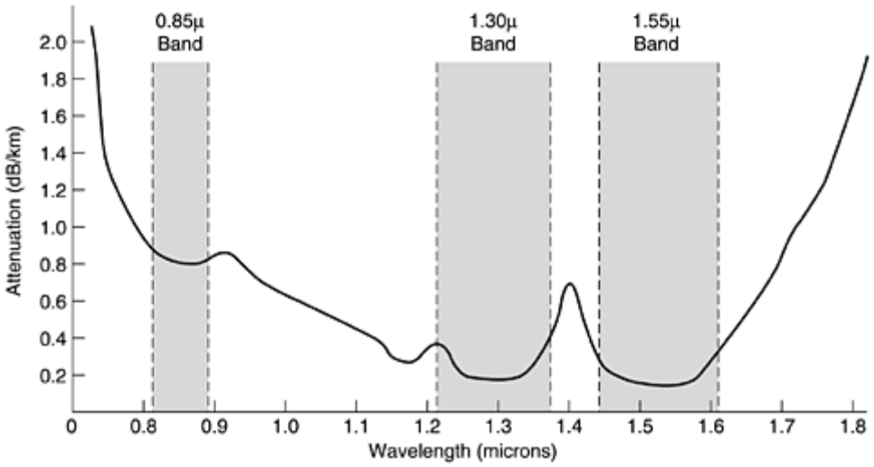
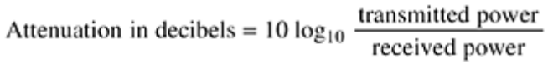

For example, a factor of two loss gives an attenuation of 10 log₁₀ 2 = 3 dB. The figure shows the near infrared part of the spectrum, which is what is used in practice. Visible light has slightly shorter wavelengths, from 0.4 to 0.7 microns (1 micron is 10⁻⁶ meters). The true metric purist would refer to these wavelengths as 400 nm to 700 nm, but we will stick with traditional usage.
Three wavelength bands are used for optical communication. They are centered at 0.85, 1.30, and 1.55 microns, respectively. The last two have good attenuation properties (less than 5 percent loss per kilometer). The 0.85 micron band has higher attenuation, but at that wavelength the lasers and electronics can be made from the same material (gallium arsenide). All three bands are 25,000 to 30,000 GHz wide.
Light pulses sent down a fiber spread out in length as they propagate. This spreading is called chromatic dispersion. The amount of it is wavelength dependent. One way to keep these spread-out pulses from overlapping is to increase the distance between them, but this can be done only by reducing the signaling rate. Fortunately, it has been discovered that by making the pulses in a special shape related to the reciprocal of the hyperbolic cosine, nearly all the dispersion effects cancel out, and it is possible to send pulses for thousands of kilometers without appreciable shape distortion. These pulses are called solitons. A considerable amount of research is going on to take solitons out of the lab and into the field.

Fiber Cables
Fiber optic cables are similar to coax, except without the braid. Figure 2-7(a) shows a single fiber viewed from the side. At the center is the glass core through which the light propagates. In multimode fibers, the core is typically 50 microns in diameter, about the thickness of a human hair. In single-mode fibers, the core is 8 to 10 microns.

Figure 2-7. (a) Side view of a single fiber. (b) End view of a sheath with three fibers.
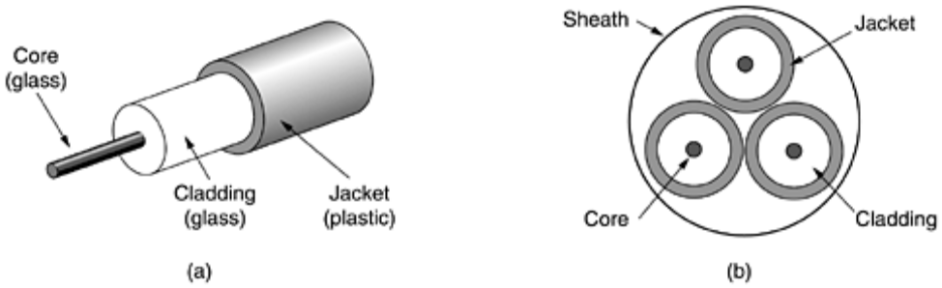
The core is surrounded by a glass cladding with a lower index of refraction than the core, to keep all the light in the core. Next comes a thin plastic jacket to protect the cladding. Fibers are typically grouped in bundles, protected by an outer sheath. Figure 2-7(b) shows a sheath with three fibers.
Terrestrial fiber sheaths are normally laid in the ground within a meter of the surface, where they are occasionally subject to attacks by backhoes or gophers. Near the shore, transoceanic fiber sheaths are buried in trenches by a kind of seaplow. In deep water, they just lie on the bottom, where they can be snagged by fishing trawlers or attacked by giant squid.
Fibers can be connected in three different ways. First, they can terminate in connectors and be plugged into fiber sockets. Connectors lose about 10 to 20 percent of the light, but they make it easy to reconfigure systems.
Second, they can be spliced mechanically. Mechanical splices just lay the two carefully-cut ends next to each other in a special sleeve and clamp them in place. Alignment can be improved by passing light through the junction and then making small adjustments to maximize the signal. Mechanical splices take trained personnel about 5 minutes and result in a 10 percent light loss.
Third, two pieces of fiber can be fused (melted) to form a solid connection. A fusion splice is almost as good as a single drawn fiber, but even here, a small amount of attenuation occurs.
For all three kinds of splices, reflections can occur at the point of the splice, and the reflected energy can interfere with the signal.
Two kinds of light sources are typically used to do the signaling, LEDs (Light Emitting Diodes) and semiconductor lasers. They have different properties, as shown in Fig. 2-8. They can be tuned in wavelength by inserting Fabry-Perot or Mach-Zehnder interferometers between the source and the fiber. Fabry-Perot interferometers are simple resonant cavities consisting of two parallel mirrors. The light is incident perpendicular to the mirrors. The length of the cavity selects out those wavelengths that fit inside an integral number of times. Mach-Zehnder interferometers separate the light into two beams. The two beams travel slightly different distances. They are recombined at the end and are in phase for only certain wavelengths.

Figure 2-8. A comparison of semiconductor diodes and LEDs as light sources.
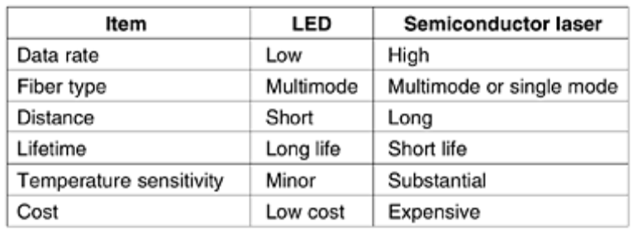
The receiving end of an optical fiber consists of a photodiode, which gives off an electrical pulse when struck by light. The typical response time of a photodiode is 1 nsec, which limits data rates to about 1 Gbps. Thermal noise is also an issue, so a pulse of light must carry enough energy to be detected. By making the pulses powerful enough, the error rate can be made arbitrarily small.

Fiber Optic Networks
Fiber optics can be used for LANs as well as for long-haul transmission, although tapping into it is more complex than connecting to an Ethernet. One way around the problem is to realize that a ring network is really just a collection of point-to-point links, as shown in Fig. 2-9. The interface at each computer passes the light pulse stream through to the next link and also serves as a T junction to allow the computer to send and accept messages.

Figure 2-9. A fiber optic ring with active repeaters.
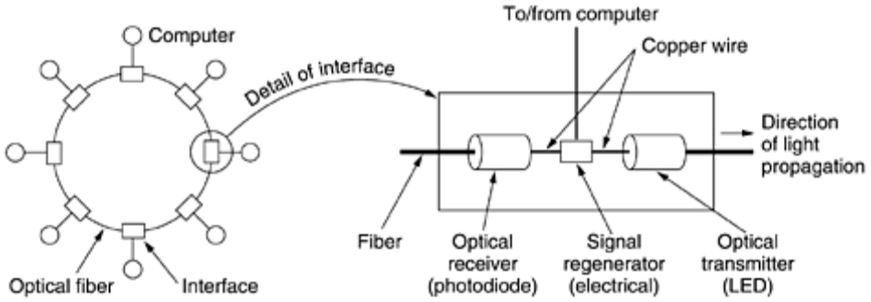
Two types of interfaces are used. A passive interface consists of two taps fused onto the main fiber. One tap has an LED or laser diode at the end of it (for transmitting), and the other has a photodiode (for receiving). The tap itself is completely passive and is thus extremely reliable because a broken LED or photodiode does not break the ring. It just takes one computer off-line.
The other interface type, shown in Fig. 2-9, is the active repeater. The incoming light is converted to an electrical signal, regenerated to full strength if it has been weakened, and retransmitted as light. The interface with the computer is an ordinary copper wire that comes into the signal regenerator. Purely optical repeaters are now being used, too. These devices do not require the optical to electrical to optical conversions, which means they can operate at extremely high bandwidths.
If an active repeater fails, the ring is broken and the network goes down. On the other hand, since the signal is regenerated at each interface, the individual computer-to-computer links can be kilometers long, with virtually no limit on the total size of the ring. The passive interfaces lose light at each junction, so the number of computers and total ring length are greatly restricted.
A ring topology is not the only way to build a LAN using fiber optics. It is also possible to have hardware broadcasting by using the passive star construction of Fig. 2-10. In this design, each interface has a fiber running from its transmitter to a silica cylinder, with the incoming fibers fused to one end of the cylinder. Similarly, fibers fused to the other end of the cylinder are run to each of the receivers. Whenever an interface emits a light pulse, it is diffused inside the passive star to illuminate all the receivers, thus achieving broadcast. In effect, the passive star combines all the incoming signals and transmits the merged result on all lines. Since the incoming energy is divided among all the outgoing lines, the number of nodes in the network is limited by the sensitivity of the photodiodes.

Figure 2-10. A passive star connection in a fiber optics network.
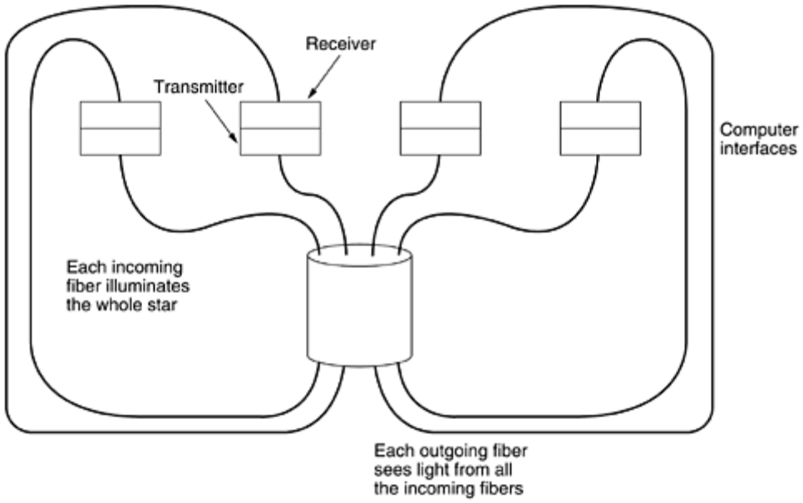

Comparison of Fiber Optics and Copper Wire
It is instructive to compare fiber to copper. Fiber has many advantages. To start with, it can handle much higher bandwidths than copper. This alone would require its use in high-end networks. Due to the low attenuation, repeaters are needed only about every 50 km on long lines, versus about every 5 km for copper, a substantial cost saving. Fiber also has the advantage of not being affected by power surges, electromagnetic interference, or power failures. Nor is it affected by corrosive chemicals in the air, making it ideal for harsh factory environments.
Oddly enough, telephone companies like fiber for a different reason: it is thin and lightweight. Many existing cable ducts are completely full, so there is no room to add new capacity. Removing all the copper and replacing it by fiber empties the ducts, and the copper has excellent resale value to copper refiners who see it as very high grade ore. Also, fiber is much lighter than copper. One thousand twisted pairs 1 km long weigh 8000 kg. Two fibers have more capacity and weigh only 100 kg, which greatly reduces the need for expensive mechanical support systems that must be maintained. For new routes, fiber wins hands down due to its much lower installation cost.
Finally, fibers do not leak light and are quite difficult to tap. These properties gives fiber excellent security against potential wiretappers.
On the downside, fiber is a less familiar technology requiring skills not all engineers have, and fibers can be damaged easily by being bent too much. Since optical transmission is inherently unidirectional, two-way communication requires either two fibers or two frequency bands on one fiber. Finally, fiber interfaces cost more than electrical interfaces. Nevertheless, the future of all fixed data communication for distances of more than a few meters is clearly with fiber. For a discussion of all aspects of fiber optics and their networks, see (Hecht, 2001).

WIRELESS TRANSMISSION
Our age has given rise to information junkies: people who need to be on-line all the time. For these mobile users, twisted pair, coax, and fiber optics are of no use. They need to get their hits of data for their laptop, notebook, shirt pocket, palmtop, or wristwatch computers without being tethered to the terrestrial communication infrastructure. For these users, wireless communication is the answer. In the following sections, we will look at wireless communication in general, as it has many other important applications besides providing connectivity to users who want to surf the Web from the beach.
Some people believe that the future holds only two kinds of communication: fiber and wireless. All fixed (i.e., non mobile) computers, telephones, faxes, and so on will use fiber, and all mobile ones will use wireless.
Wireless has advantages for even fixed devices in some circumstances. For example, if running a fiber to a building is difficult due to the terrain (mountains, jungles, swamps, etc.), wireless may be better. It is noteworthy that modern wireless digital communication began in the Hawaiian Islands, where large chunks of Pacific Ocean separated the users and the telephone system was inadequate.

The Electromagnetic Spectrum
When electrons move, they create electromagnetic waves that can propagate through space (even in a vacuum). These waves were predicted by the British physicist James Clerk Maxwell in 1865 and first observed by the German physicist Heinrich Hertz in 1887. The number of oscillations per second of a wave is called its frequency, f, and is measured in Hz (in honor of Heinrich Hertz). The distance between two consecutive maxima (or minima) is called the wavelength, which is universally designated by the Greek letter l (lambda).
When an antenna of the appropriate size is attached to an electrical circuit, the electromagnetic waves can be broadcast efficiently and received by a receiver some distance away. All wireless communication is based on this principle.
In vacuum, all electromagnetic waves travel at the same speed, no matter what their frequency. This speed, usually called the speed of light, c, is approximately 3 x 10⁸ m/sec, or about 1 foot (30 cm) per nanosecond. (A case could be made for redefining the foot as the distance light travels in a vacuum in 1 nsec rather than basing it on the shoe size of some long-dead king.) In copper or fiber the speed slows to about 2/3 of this value and becomes slightly frequency dependent. The speed of light is the ultimate speed limit. No object or signal can ever move faster than it.
The fundamental relation between f, l, and c (in vacuum) is
Equation 2
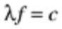
Since c is a constant, if we know f, we can find l, and vice versa. As a rule of thumb, when l is in meters and f is in MHz, lf 300. For example, 100-MHz waves are about 3 meters long, 1000-MHz waves are 0.3-meters long, and 0.1-meter waves have a frequency of 3000 MHz.
The electromagnetic spectrum is shown in Fig. 2-11. The radio, microwave, infrared, and visible light portions of the spectrum can all be used for transmitting information by modulating the amplitude, frequency, or phase of the waves. Ultraviolet light, X-rays, and gamma rays would be even better, due to their higher frequencies, but they are hard to produce and modulate, do not propagate well through buildings, and are dangerous to living things. The bands listed at the bottom of Fig. 2-11 are the official ITU names and are based on the wavelengths, so the LF band goes from 1 km to 10 km (approximately 30 kHz to 300 kHz). The terms LF, MF, and HF refer to low, medium, and high frequency, respectively. Clearly, when the names were assigned, nobody expected to go above 10 MHz, so the higher bands were later named the Very, Ultra, Super, Extremely, and Tremendously High Frequency bands. Beyond that there are no names, but Incredibly, Astonishingly, and Prodigiously high frequency (IHF, AHF, and PHF) would sound nice.

Figure 2-11. The electromagnetic spectrum and its uses for communication.
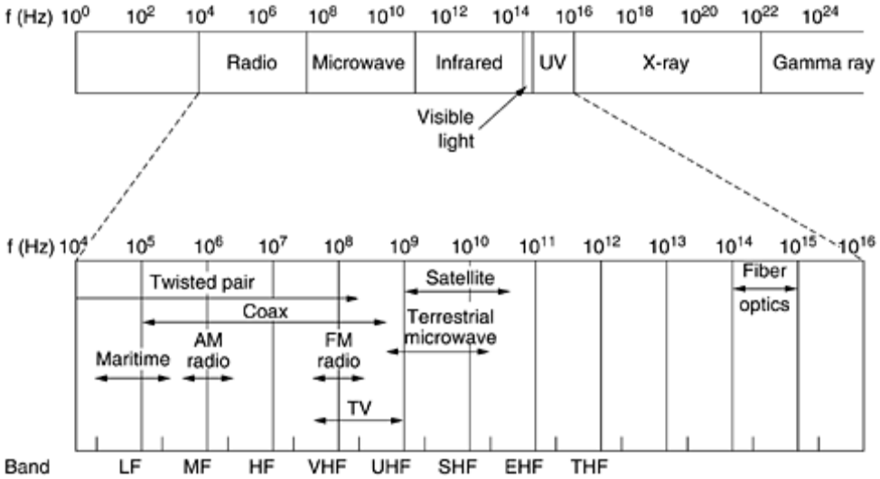
The amount of information that an electromagnetic wave can carry is related to its bandwidth. With current technology, it is possible to encode a few bits per Hertz at low frequencies, but often as many as 8 at high frequencies, so a coaxial cable with a 750 MHz bandwidth can carry several gigabits/sec. From Fig. 2-11 it should now be obvious why networking people like fiber optics so much.
If we solve Eq. (2-2) for f and differentiate with respect to l, we get
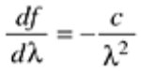

If we now go to finite differences instead of differentials and only look at absolute values, we get
Equation 2
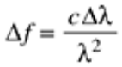

Thus, given the width of a wavelength band, Dl, we can compute the corresponding frequency band, Df, and from that the data rate the band can produce. The wider the band, the higher the data rate. As an example, consider the 1.30-micron band of Fig. 2-6. Here we have l=1.3 x 10⁻⁶ and Dl = 0.17 x 10⁻⁶,soDf is about 30 THz. At, say, 8 bits/Hz, we get 240 Tbps.
Most transmissions use a narrow frequency band (i.e., Df/f 1) to get the best reception (many watts/Hz). However, in some cases, a wide band is used, with two variations. In frequency hopping spread spectrum, the transmitter hops from frequency to frequency hundreds of times per second. It is popular for military communication because it makes transmissions hard to detect and next to impossible to jam. It also offers good resistance to multipath fading because the direct signal always arrives at the receiver first. Reflected signals follow a longer path and arrive later. By then the receiver may have changed frequency and no longer accepts signals on the previous frequency, thus eliminating interference between the direct and reflected signals. In recent years, this technique has also been applied commercially—both 802.11 and Bluetooth use it, for example.
As a curious footnote, the technique was co-invented by the Austrian-born sex goddess Hedy Lamarr, the first woman to appear nude in a motion picture (the 1933 Czech film Extase). Her first husband was an armaments manufacturer who told her how easy it was to block the radio signals then used to control torpedos. When she discovered that he was selling weapons to Hitler, she was horrified, disguised herself as a maid to escape him, and fled to Hollywood to continue her career as a movie actress. In her spare time, she invented frequency hopping to help the Allied war effort. Her scheme used 88 frequencies, the number of keys (and frequencies) on the piano. For their invention, she and her friend, the musical composer George Antheil, received U.S. patent 2,292,387. However, they were unable to convince the U.S. Navy that their invention had any practical use and never received any royalties. Only years after the patent expired did it become popular.
The other form of spread spectrum, direct sequence spread spectrum, which spreads the signal over a wide frequency band, is also gaining popularity in the commercial world. In particular, some second-generation mobile phones use it, and it will become dominant with the third generation, thanks to its good spectral efficiency, noise immunity, and other properties. Some wireless LANs also use it. We will come back to spread spectrum later in this chapter. For a fascinating and detailed history of spread spectrum communication, see (Scholtz, 1982).
For the moment, we will assume that all transmissions use a narrow frequency band. We will now discuss how the various parts of the electromagnetic spectrum of Fig. 2-11 are used, starting with radio.

Radio Transmission
Radio waves are easy to generate, can travel long distances, and can penetrate buildings easily, so they are widely used for communication, both indoors and outdoors. Radio waves also are omnidirectional, meaning that they travel in all directions from the source, so the transmitter and receiver do not have to be carefully aligned physically.
Sometimes omnidirectional radio is good, but sometimes it is bad. In the 1970s, General Motors decided to equip all its new Cadillacs with computer-controlled antilock brakes. When the driver stepped on the brake pedal, the computer pulsed the brakes on and off instead of locking them on hard. One fine day an Ohio Highway Patrolman began using his new mobile radio to call headquarters, and suddenly the Cadillac next to him began behaving like a bucking bronco. When the officer pulled the car over, the driver claimed that he had done nothing and that the car had gone crazy.
Eventually, a pattern began to emerge: Cadillacs would sometimes go berserk, but only on major highways in Ohio and then only when the Highway Patrol was watching. For a long, long time General Motors could not understand why Cadillacs worked fine in all the other states and also on minor roads in Ohio. Only after much searching did they discover that the Cadillac's wiring made a fine antenna for the frequency used by the Ohio Highway Patrol's new radio system.
The properties of radio waves are frequency dependent. At low frequencies, radio waves pass through obstacles well, but the power falls off sharply with distance from the source, roughly as 1/r² in air. At high frequencies, radio waves tend to travel in straight lines and bounce off obstacles. They are also absorbed by rain. At all frequencies, radio waves are subject to interference from motors and other electrical equipment.
Due to radio's ability to travel long distances, interference between users is a problem. For this reason, all governments tightly license the use of radio transmitters, with one exception, discussed below.
In the VLF, LF, and MF bands, radio waves follow the ground, as illustrated in Fig. 2-12(a). These waves can be detected for perhaps 1000 km at the lower frequencies, less at the higher ones. AM radio broadcasting uses the MF band, which is why the ground waves from Boston AM radio stations cannot be heard easily in New York. Radio waves in these bands pass through buildings easily, which is why portable radios work indoors. The main problem with using these bands for data communication is their low bandwidth [see Eq. (2-3)].

Figure 2-12. (a) In the VLF, LF, and MF bands, radio waves follow the curvature of the earth. (b) In the HF band, they bounce off the ionosphere.
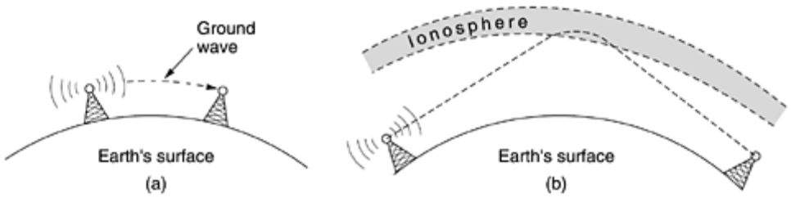
In the HF and VHF bands, the ground waves tend to be absorbed by the earth. However, the waves that reach the ionosphere, a layer of charged particles circling the earth at a height of 100 to 500 km, are refracted by it and sent back to earth, as shown in Fig. 2-12(b). Under certain atmospheric conditions, the signals can bounce several times. Amateur radio operators (hams) use these bands to talk long distance. The military also communicate in the HF and VHF bands.

Microwave Transmission
Above 100 MHz, the waves travel in nearly straight lines and can therefore be narrowly focused. Concentrating all the energy into a small beam by means of a parabolic antenna (like the familiar satellite TV dish) gives a much higher signal-to-noise ratio, but the transmitting and receiving antennas must be accurately aligned with each other. In addition, this directionality allows multiple transmitters lined up in a row to communicate with multiple receivers in a row without interference, provided some minimum spacing rules are observed. Before fiber optics, for decades these microwaves formed the heart of the long-distance telephone transmission system. In fact, MCI, one of AT&T's first competitors after it was deregulated, built its entire system with microwave communications going from tower to tower tens of kilometers apart. Even the company's name reflected this (MCI stood for Microwave Communications, Inc.). MCI has since gone over to fiber and merged with WorldCom.
Since the microwaves travel in a straight line, if the towers are too far apart, the earth will get in the way (think about a San Francisco to Amsterdam link). Consequently, repeaters are needed periodically. The higher the towers are, the farther apart they can be. The distance between repeaters goes up very roughly with the square root of the tower height. For 100-meter-high towers, repeaters can be spaced 80 km apart.
Unlike radio waves at lower frequencies, microwaves do not pass through buildings well. In addition, even though the beam may be well focused at the transmitter, there is still some divergence in space. Some waves may be refracted off low-lying atmospheric layers and may take slightly longer to arrive than the direct waves. The delayed waves may arrive out of phase with the direct wave and thus cancel the signal. This effect is called multipath fading and is often a serious problem. It is weather and frequency dependent. Some operators keep 10 percent of their channels idle as spares to switch on when multipath fading wipes out some frequency band temporarily.
The demand for more and more spectrum drives operators to yet higher frequencies. Bands up to 10 GHz are now in routine use, but at about 4 GHz a new problem sets in: absorption by water. These waves are only a few centimeters long and are absorbed by rain. This effect would be fine if one were planning to build a huge outdoor microwave oven for roasting passing birds, but for communication, it is a severe problem. As with multipath fading, the only solution is to shut off links that are being rained on and route around them.
In summary, microwave communication is so widely used for long-distance telephone communication, mobile phones, television distribution, and other uses that a severe shortage of spectrum has developed. It has several significant advantages over fiber. The main one is that no right of way is needed, and by buying a small plot of ground every 50 km and putting a microwave tower on it, one can bypass the telephone system and communicate directly. This is how MCI managed to get started as a new long-distance telephone company so quickly. (Sprint went a completely different route: it was formed by the Southern Pacific Railroad, which already owned a large amount of right of way and just buried fiber next to the tracks.)
Microwave is also relatively inexpensive. Putting up two simple towers (may be just big poles with four guy wires) and putting antennas on each one may be cheaper than burying 50 km of fiber through a congested urban area or up over a mountain, and it may also be cheaper than leasing the telephone company's fiber, especially if the telephone company has not yet even fully paid for the copper it ripped out when it put in the fiber.

The Politics of the Electromagnetic Spectrum
To prevent total chaos, there are national and international agreements about who gets to use which frequencies. Since everyone wants a higher data rate, everyone wants more spectrum. National governments allocate spectrum for AM and FM radio, television, and mobile phones, as well as for telephone companies, police, maritime, navigation, military, government, and many other competing users. Worldwide, an agency of ITU-R (WARC) tries to coordinate this allocation so devices that work in multiple countries can be manufactured. However, countries are not bound by ITU-R's recommendations, and the FCC (Federal Communication Commission), which does the allocation for the United States, has occasionally rejected ITU-R's recommendations (usually because they required some politically-powerful group giving up some piece of the spectrum).
Even when a piece of spectrum has been allocated to some use, such as mobile phones, there is the additional issue of which carrier is allowed to use which frequencies. Three algorithms were widely used in the past. The oldest algorithm, often called the beauty contest, requires each carrier to explain why its proposal serves the public interest best. Government officials then decide which of the nice stories they enjoy most. Having some government official award property worth billions of dollars to his favorite company often leads to bribery, corruption, nepotism, and worse. Furthermore, even a scrupulously honest government official who thought that a foreign company could do a better job than any of the national companies would have a lot of explaining to do.
This observation led to algorithm 2, holding a lottery among the interested companies. The problem with that idea is that companies with no interest in using the spectrum can enter the lottery. If, say, a fast food restaurant or shoe store chain wins, it can resell the spectrum to a carrier at a huge profit and with no risk.
Bestowing huge windfalls on alert, but otherwise random, companies has been severely criticized by many, which led to algorithm 3: auctioning off the bandwidth to the highest bidder. When England auctioned off the frequencies needed for third-generation mobile systems in 2000, they expected to get about $4 billion. They actually received about $40 billion because the carriers got into a feeding frenzy, scared to death of missing the mobile boat. This event switched on nearby governments' greedy bits and inspired them to hold their own auctions. It worked, but it also left some of the carriers with so much debt that they are close to bankruptcy. Even in the best cases, it will take many years to recoup the licensing fee.
A completely different approach to allocating frequencies is to not allocate them at all. Just let everyone transmit at will but regulate the power used so that stations have such a short range they do not interfere with each other. Accordingly, most governments have set aside some frequency bands, called the ISM (Industrial, Scientific, Medical) bands for unlicensed usage. Garage door openers, cordless phones, radio-controlled toys, wireless mice, and numerous other wireless household devices use the ISM bands. To minimize interference between these uncoordinated devices, the FCC mandates that all devices in the ISM bands use spread spectrum techniques. Similar rules apply in other countries
The location of the ISM bands varies somewhat from country to country. In the United States, for example, devices whose power is under 1 watt can use the bands shown in Fig. 2-13 without requiring a FCC license. The 900-MHz band works best, but it is crowded and not available worldwide. The 2.4-GHz band is available in most countries, but it is subject to interference from microwave ovens and radar installations. Bluetooth and some of the 802.11 wireless LANs operate in this band. The 5.7-GHz band is new and relatively undeveloped, so equipment for it is expensive, but since 802.11a uses it, it will quickly become more popular.

Figure 2-13. The ISM bands in the United States.
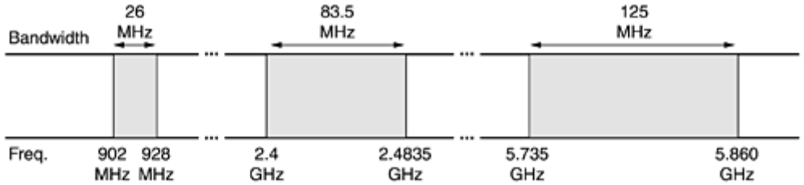

Infrared and Millimeter Waves
Unguided infrared and millimeter waves are widely used for short-range communication. The remote controls used on televisions, VCRs, and stereos all use infrared communication. They are relatively directional, cheap, and easy to build but have a major drawback: they do not pass through solid objects (try standing between your remote control and your television and see if it still works). In general, as we go from long-wave radio toward visible light, the waves behave more and more like light and less and less like radio.
On the other hand, the fact that infrared waves do not pass through solid walls well is also a plus. It means that an infrared system in one room of a building will not interfere with a similar system in adjacent rooms or buildings: you cannot control your neighbor's television with your remote control. Furthermore, security of infrared systems against eavesdropping is better than that of radio systems precisely for this reason. Therefore, no government license is needed to operate an infrared system, in contrast to radio systems, which must be licensed outside the ISM bands. Infrared communication has a limited use on the desktop, for example, connecting notebook computers and printers, but it is not a major player in the communication game.

Lightwave Transmission
Unguided optical signaling has been in use for centuries. Paul Revere used binary optical signaling from the Old North Church just prior to his famous ride. A more modern application is to connect the LANs in two buildings via lasers mounted on their rooftops. Coherent optical signaling using lasers is inherently unidirectional, so each building needs its own laser and its own photodetector. This scheme offers very high bandwidth and very low cost. It is also relatively easy to install and, unlike microwave, does not require an FCC license.
The laser's strength, a very narrow beam, is also its weakness here. Aiming a laser beam 1-mm wide at a target the size of a pin head 500 meters away requires the marksmanship of a latter-day Annie Oakley. Usually, lenses are put into the system to defocus the beam slightly.
A disadvantage is that laser beams cannot penetrate rain or thick fog, but they normally work well on sunny days. However, the author once attended a conference at a modern hotel in Europe at which the conference organizers thoughtfully provided a room full of terminals for the attendees to read their e-mail during boring presentations. Since the local PTT was unwilling to install a large number of telephone lines for just 3 days, the organizers put a laser on the roof and aimed it at their university's computer science building a few kilometers away. They tested it the night before the conference and it worked perfectly. At 9 a.m. the next morning, on a bright sunny day, the link failed completely and stayed down all day. That evening, the organizers tested it again very carefully, and once again it worked absolutely perfectly. The pattern repeated itself for two more days consistently.
After the conference, the organizers discovered the problem. Heat from the sun during the daytime caused convection currents to rise up from the roof of the building, as shown in Fig. 2-14. This turbulent air diverted the beam and made it dance around the detector. Atmospheric ''seeing'' like this makes the stars twinkle (which is why astronomers put their telescopes on the tops of mountains—to get above as much of the atmosphere as possible). It is also responsible for shimmering roads on a hot day and the wavy images seen when one looks out above a hot radiator.

Figure 2-14. Convection currents can interfere with laser communication systems. A bidirectional system with two lasers is pictured here.
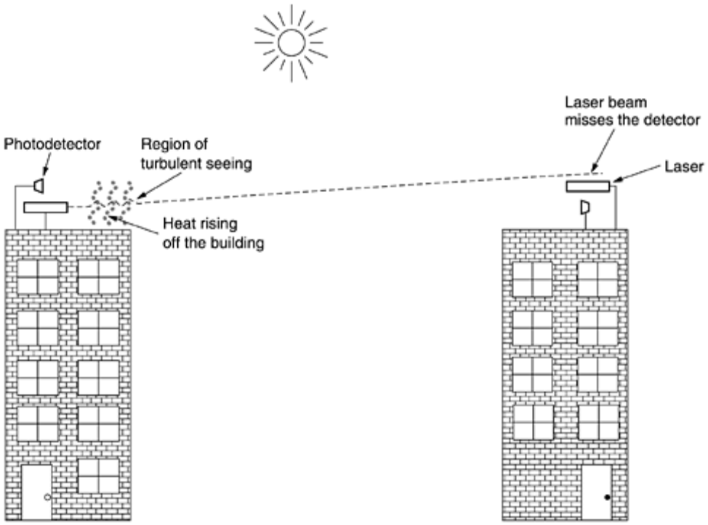

SATELLITE COMMUNICATION
Communication satellites have some interesting properties that make them attractive for many applications. In its simplest form, a communication satellite can be thought of as a big microwave repeater in the sky. It contains several transponders, each of which listens to some portion of the spectrum, amplifies the incoming signal, and then rebroadcasts it at another frequency to avoid interference with the incoming signal. The downward beams can be broad, covering a substantial fraction of the earth's surface, or narrow, covering an area only hundreds of kilometers in diameter. This mode of operation is known as a bent pipe.

According to Kepler's law, the orbital period of a satellite varies as the radius of the orbit to the 3/2 power. The higher the satellite, the longer the period. Near the surface of the earth, the period is about 90 minutes. Consequently, low-orbit satellites pass out of view fairly quickly, so many of them are needed to provide continuous coverage. At an altitude of about 35,800 km, the period is 24 hours. At an altitude of 384,000 km, the period is about one month, as anyone who has observed the moon regularly can testify.
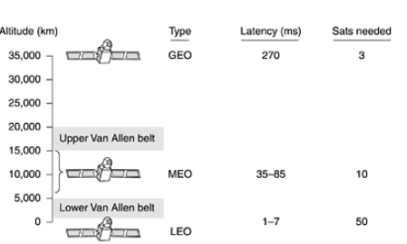
Fig 1.27: Communication satellites and some of their properties, including altitude above the earth, round-trip delay time, and number of satellites needed for global coverage.

10.1 Geostationary Satellites
The invention of the transistor changed all that, and the first artificial communication satellite, Telstar, was launched in July 1962. Since then, communication satellites have become a multibillion dollar business and the only aspect of outer space that has become highly profitable. These high-flying satellites are often called GEO (Geostationary Earth Orbit) satellites.
With current technology, it is unwise to have geostationary satellites spaced much closer than 2 degrees in the 360-degree equatorial plane, to avoid interference. With a spacing of 2 degrees, there can only be 360/2 = 180 of these satellites in the sky at once. However, each transponder can use multiple frequencies and polarizations to increase the available bandwidth.
To prevent total chaos in the sky, orbit slot allocation is done by ITU. This process is highly political, with countries barely out of the Stone Age demanding ''their'' orbit slots (for the purpose of leasing them to the highest bidder).
Modern satellites can be quite large, weighing up to 4000 kg and consuming several kilowatts of electric power produced by the solar panels. The effects of solar, lunar, and planetary gravity tend to move them away from their assigned orbit slots and orientations, an effect countered by on-board rocket motors. This fine-tuning activity is called station keeping. However, when the fuel for the motors has been exhausted, typically in about 10 years, the satellite drifts and tumbles helplessly, so it has to be turned off. Eventually, the orbit decays and the satellite reenters the atmosphere and burns up or occasionally crashes to earth.

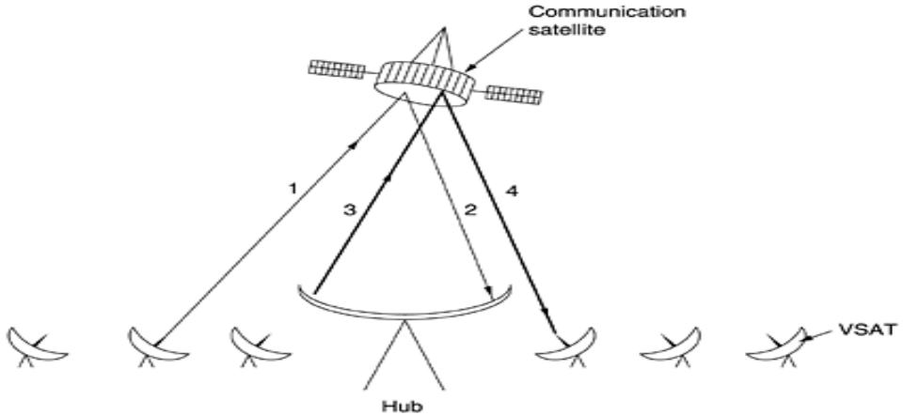
Fig 1.28: VSATs using a hub.
  - Medium-Earth Orbit Satellites
At much lower altitudes, between the two Van Allen belts, we find the MEO (Medium-Earth Orbit) satellites. As viewed from the earth, these drift slowly in longitude, taking something like 6 hours to circle the earth. Accordingly, they must be tracked as they move through the sky. Because they are lower than the GEOs, they have a smaller footprint on the ground and require less powerful transmitters to reach them. Currently they are not used for telecommunications, so we will not examine them further here. The 24 GPS (Global Positioning System) satellites orbiting at about 18,000 km are examples of MEO satellites.

  - Low-Earth Orbit Satellites
Moving down in altitude, we come to the LEO (Low-Earth Orbit) satellites. Due to their rapid motion, large numbers of them are needed for a complete system. On the other hand, because the satellites are so close to the earth, the ground stations do not need much power, and the round-trip delay is only a few milliseconds.
  - Iridium
As mentioned above, for the first 30 years of the satellite era, low-orbit satellites were rarely used because they zip into and out of view so quickly. In 1990, Motorola broke new ground by filing an application with the FCC asking for permission to launch 77 low-orbit satellites for the Iridium project (element 77 is iridium). The plan was later revised to use only 66 satellites, so the project should have been renamed Dysprosium (element 66), but that probably sounded too much like a disease. The idea was that as soon as one satellite went out of view, another would replace it. This proposal set off a feeding frenzy among other communication companies. All of a sudden, everyone wanted to launch a chain of low-orbit satellites.
After seven years of cobbling together partners and financing, the partners launched the Iridium satellites in 1997. Communication service began in November 1998. Unfortunately, the commercial demand for large, heavy satellite telephones was negligible because the mobile phone network had grown spectacularly since 1990. As a consequence, Iridium was not profitable and was forced into bankruptcy in August 1999 in one of the most spectacular corporate fiascos in history. The satellites and other assets (worth $5 billion) were subsequently purchased by an investor for $25 million at a kind of extraterrestrial garage sale. The Iridium service was restarted in March 2001.
Iridium's business was (and is) providing worldwide telecommunication service using hand-held devices that communicate directly with the Iridium satellites. It provides voice, data, paging, fax, and navigation service everywhere on land, sea, and air. Customers include the maritime, aviation, and oil exploration industries, as well as people traveling in parts of the world lacking a telecommunications infrastructure (e.g., deserts, mountains, jungles, and some Third World countries).
The Iridium satellites are positioned at an altitude of 750 km, in circular polar orbits.
  - Globalstar
An alternative design to Iridium is Globalstar. It is based on 48 LEO satellites but uses a different switching scheme than that of Iridium. Whereas Iridium relays calls from satellite to satellite, which requires sophisticated switching equipment in the satellites, Globalstar uses a traditional bent-pipe design. The call originating at the North Pole is sent back to earth and picked up by the large ground station at Santa's Workshop.
The call is then routed via a terrestrial network to the ground station nearest the callee and delivered by a bent-pipe connection as shown. The advantage of this scheme is that it puts much of the complexity on the ground, where it is easier to manage. Also, the use of large ground station antennas that can put out a powerful signal and receive a weak one means that lower-powered telephones can be used. After all, the telephone puts out only a few milliwatts of power, so the signal that gets back to the ground station is fairly weak, even after having been amplified by the satellite.
  - Teledesic
Iridium is targeted at telephone users located in odd places. Our next example, Teledesic, is targeted at bandwidth-hungry Internet users all over the world. It was conceived in 1990 by mobile phone pioneer Craig McCaw and Microsoft founder Bill Gates, who was unhappy with the snail's pace at which the world's telephone companies were providing high bandwidth to computer users. The goal of the Teledesic system is to provide millions of concurrent Internet users with an uplink of as much as 100 Mbps and a downlink of up to 720 Mbps using a small, fixed, VSAT-type antenna, completely bypassing the telephone system. To telephone companies, this is pie-in-the-sky.
The original design was for a system consisting of 288 small-footprint satellites arranged in 12 planes just below the lower Van Allen belt at an altitude of 1350 km. This was later changed to 30 satellites with larger footprints. Transmission occurs in the relatively uncrowded and high-bandwidth Ka band. The system is packet-switched in space, with each satellite capable of routing packets to its neighboring satellites. When a user needs bandwidth to send packets, it is requested and assigned dynamically in about 50 msec.

